

Feedback and Presentation Policy

Published: January 2024

Date | Reviewer | Changes made
11 Jan 24 | KON | New policy
1 Sept 24 | KON | Update to logo, update to presentation guides, update to marking codes for children’s books.

Rationale

At Albany, WE ARE PROUD. This value MUST be modelled throughout school by all staff, including feedback and presentation. High expectations of presentation and quality of feedback need to be consistent across school to enable our children to achieve. Our policy is underpinned by the evidence of best practice from the Education Endowment Foundation (EEF). The EEF research shows that effective feedback should:

- Redirect or refocus either the teacher’s or the learner’s actions to achieve a goal
- Be specific, accurate and clear
- Encourage and support further effort
- Is meaningful
- Provide specific guidance on how to improve and not just tell pupils when they are wrong
Aims of the Policy:
- To provide consistency and clarity in feedback throughout the school so that pupils have a clear understanding of teacher expectations and their learning journey.
- To set out our expectations for high quality but manageable feedback, provide a coherent picture of outstanding practice and to support teacher workload.
- To use feedback as a tool for formative ongoing assessment, ensure children are effectively challenged and visible progress is evident.
- To give teachers, teaching assistants and peers the skills for effective feedback strategies.
- To develop children’s’ positive attitudes to learning and achievement.

Feedback should:

- Be manageable for teachers, accessible to pupils and relate to the Learning Intention.
- Give recognition and praise for achievement.
- Give clear strategies for improvement and result in better pupil achievement.
- Allow specific time for pupils to read, reflect and respond to marking.
- Be personalised to individual learning needs and inform future planning and group tasks.
- Be consistent to ensure impact.
- Be a tool to narrow the gap to end of year expectations to allow all pupils to achieve

Feedback Expectations

- Pupils’ work is marked in black so it can clearly be seen and is consistent across the school.
- Teacher’s handwriting in comments must be legible to the child and follow the handwriting script used in school.
- A black tick next to the LI indicates that it has been met.
- Intervention Response (IR) is written in black next to the LI, when a child has failed to meet the LI and support / intervention is needed in order for them to achieve it.
- Feedback codes are used (See Appendix 1).
- Time for children to respond to feedback given outside of the lesson needs to be built into lesson time (preferably at the start).

Maths Specific Feedback:

- All questions/tasks in workbooks, across school, must be marked (can be teacher/self/peer – but MUST be checked by teacher).
Presentation Expectations

- WE ARE PROUD. Children must take pride and care in the presentation of their books reflecting the high standard that is expected e.g. never use graffiti, doodle or scribble on or in books.
- Worksheets glued all the way round the edges. Sheets, LI’s etc to be stuck in neatly.
- Worksheets should be trimmed and stuck in well within the boundaries of the book if used at all
- Underline using a ruler and pencil.
- Cross out mistakes neatly using a pencil / pen and ruler. We do not advocate the use of rubbers regularly as we teach our children that mistakes help the learning process and therefore are helpful.
- Use pencil for drawing or diagrams.
- Record the long date neatly and correctly in English and Learning Journals and underline.
- Record the short date neatly and correctly in Maths.
- In EYFS and Year One – autumn term, the Learning Intention is to be stuck in neatly.
- From Year One spring term onwards, the date and Learning Intention should be written following the DUMLUMS (date, underline, miss a line, Learning intention, underline, miss a line, start) approach.
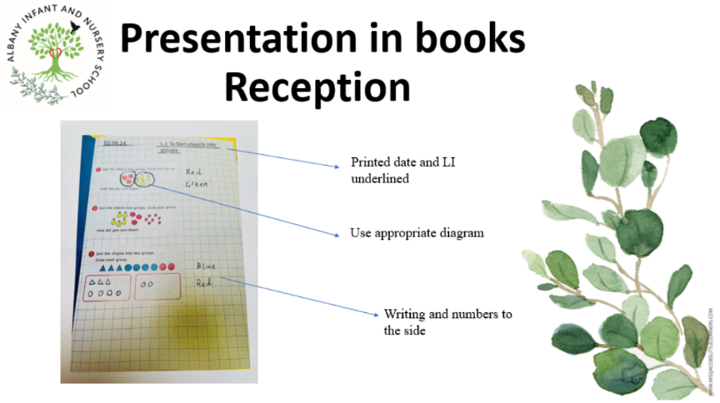
- Underlining with a ruler begins in the Spring Term in Year One.

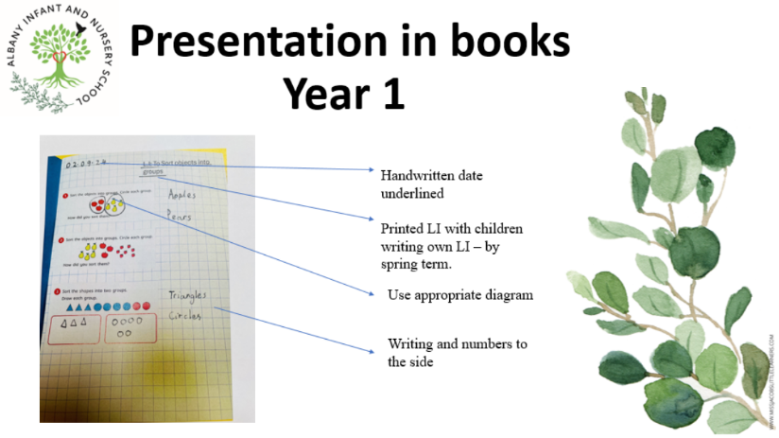
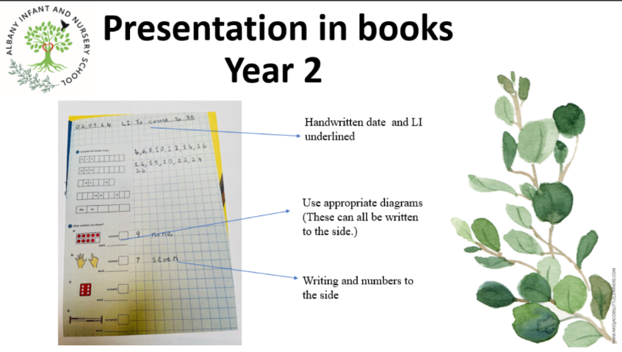
Feedback Type | What it looks like | Evidence (for observers)
In the moment | - Includes teacher gathering feedback from teaching, including mini-whiteboards, book work, etc.  - Takes place in lessons with individuals or small groups  - Often given verbally to pupils for immediate action  - May re-direct the focus of teaching  - May lead to the adaptation of a task to enable every child to make progress  - May involve giving additional tasks to extend learning  - May involve use of a teaching assistant to provide support or further challenge  - May include annotations according to the marking conventions  - Whole class involvement – such as Pose, Pause, Pounce, Bounce, tennis ball bouncing ideas etc. | - Lesson observations/learning walks  - Some use of episodic plenaries / lesson reflections throughout learning  - May include evidence of children receiving and/or responding to feedback (for example, green pen)  - Some evidence of annotations or use of marking conventions
Summary | - Takes place at the end of a lesson or activity  - Often involves whole groups or classes  - Provides an opportunity for evaluation of learning in the lesson  - May take form of self- or peer- assessment against an agreed set of criteria  - May be at the reflection point of a lesson  - In some cases, may guide a teacher’s further use of review feedback, focusing on areas of need | - Lesson observations/learning walks  - Timetabled pre- and post-teaching based on assessment  - Some evidence of self- and peer assessment (use of marking stations may be appropriate)  - May be reflected in selected focus review feedback (marking)  - Is identified through the ‘reactivate’ element of the lesson
Review | - Takes place away from the point of teaching  - Provides teachers with opportunities for assessment of understanding  - May lead to adaptation of future lessons through planning, grouping or adaptation of tasks  - May lead to targets being set for pupils’ future attention, or immediate action (for example, following whole-class feedback)  - May identify pupils who will benefit from pre- or post-teaching. | - Acknowledgement of work completed  - Written comments which may lead to a pupil response/action  - Adaptations to teaching sequences tasks when compared to planning  - Use of annotations to indicate future groupings  - Is identified through the ‘reactivate’ element of the lesson

Presentation Rewards
Stamp | Rationale
A presentation certificate  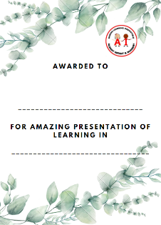 | Share, Celebrate and Reward  Children to be rewarded for producing an outstanding, exemplary piece of work that is shared and celebrated with peers in class and sent home for parents to add to the celebration.  This experience celebrates and rewards a child when their work reflects ‘above and beyond’ effort and outstanding output for the individual. The child’s work is of an exemplary standard and could be used as a model in the classroom for others.  This recognises and rewards a child when their work shows an element of excellence or a combination of great effort, content and presentation.
A celebratory conversation with Headteacher/class teacher  Sticker   | Share, Celebrate and Reward  Children to be rewarded for producing an outstanding, exemplary piece of work that is shared and celebrated with class teachers or headteachers.  This experience celebrates and rewards a child when their work reflects ‘above and beyond’ effort and outstanding output for the individual. The child’s work is of an exemplary standard and could be used as a model.  The proud stamp/sticker is in line with the behaviour policy, where role model behaviour / contributions are celebrated.  Children understand that this experience means that they visit headteacher’s office or another classroom for a 1:1 celebratory conversation and a sticker.  This recognises and rewards a child when their work shows an element of excellence or a combination of great effort, content and presentation.
  1 x Dojo Point | Recognise and Reward  Children to be rewarded for producing a great piece of work that is worthy of a dojo point for PROUD.  This reward is in line with behaviour policy, where children’s great behaviour / contributions are recognised through a dojo point.

Appendix One – Feedback Codes

Dates should be written as follows: | Maths  dd/mm/yyyy | All other subjects  day month year
Support level indicated on Learning Intention
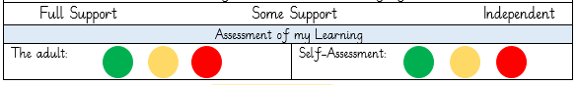
Assessment of learning indicated by staff and self.
All teacher mark in black biro pen
Children edit or respond in blue biro pen
c a t | Use ‘sound buttons’ to indicate where the child has to apply the sounds
r ai n | Use a line to show the application of digraph or trigraph is needed
 | Finger space needed.
 | Capital letter needed.
 | Word missed out
 | Full stop needed.
 | Improvement suggestions/target to respond to
 | Indicates an element of the learning intention achieved well.
WS | Work has been supported by an adult
Box around the word with line to the space to make correction | Indicates a spelling error in a common exception word or high frequency words for the year group.
Pencil stamp and start point | Letter to formed correctly by pupil in response 5 times
Underlined sentence | Sentence to be re written by the responding pupil in blue pen

Dates should be written as follows: | Maths  dd/mm/yyyy | All other subjects  day month year
All teacher mark in black biro pen
I can edit or respond in blue biro pen
c a t | I need to use my sounds
r ai n | I have missed a trigraph or diagraph
 | I missed a finger space.
 | I have used the wrong sized letter.
 | I have missed a word out.
 | I have missed a full stop.
 | I need to make improvements based on my teacher’s suggestions
 | I have done this really well.
WS | I had help with this
 | I have misspelled a common exception word
Pencil | I need to form my letters and numbers correctly
Underlined sentence | I need to rewrite my sentence to make sure it makes sense.

