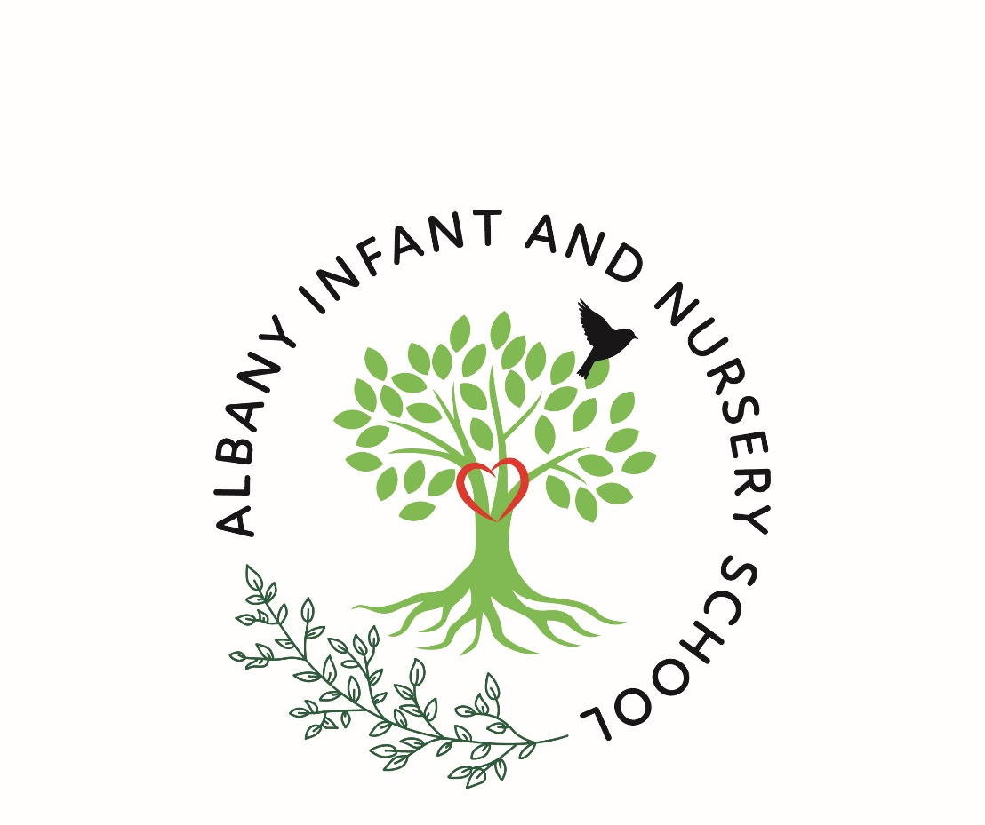

Child-on-Child Abuse Policy

Date | Reviewer | Amendments | Next review
Nov 23 | KON | In line with NSCP and KCSiE 2023 | Sept 24
Sept 24 | KON | Update logo  Change DSL names and contacts | Sept 25 or in line with LA policy development

Introduction
At Albany Infant and Nursery School we have a zero-tolerance approach to all forms of child-on-child abuse including sexual violence, sexual harassment (SVSH) and harmful sexual behaviour (HSB). We believe that child-on-child abuse is never acceptable, and it will not be tolerated. It will never be passed off as “banter,” “just having a laugh,” “a part of growing up” or “boys being boys.” We will respond to all signs, reports, and concerns of child-on-child abuse, including those that have happened outside of our school premises, and/or online. We recognise that children are vulnerable to and capable of abusing their peers, we take such abuse as seriously as abuse perpetrated by an adult. We recognise that even if there are no reports it does not mean it is not happening, it may be the case that it is just not being reported. We acknowledge that children who have allegedly abused their peers or displayed harmful sexual behaviour are themselves vulnerable. We are committed to a whole school approach to ensure the prevention, early identification, and appropriate management of child-on-child abuse within our school and beyond.
In cases where child-on-child abuse is suspected or identified we will follow our Child Protection procedures, taking a contextual, trauma-informed, and strengths-based approach to support all children who have been affected by the situation including the victim and alleged perpetrator.

Policy Development
All schools need to include child-on-child abuse in their school’s policies and procedures and all staff need to be aware of these and ensure they are part of their everyday practice. Children also need to know how to report concerns and to know that they will be listened to and supported. It is important that schools see this guidance and model policy as a framework that will need to be adapted to fit the age and developmental stage and understanding of their pupil group. A policy template is attached to this document, the areas in red are for you to amend and ensure they reflect your school’s current practice.
Policy Development
This guidance and associated Policy Template for Child-on-Child Abuse has been written to reflect the most recent Keeping Children Safe in Education (KCSiE) Statutory Guidance (1 September 2023) Keeping children safe in education - GOV.UK (www.gov.uk)
The term ‘peer on peer abuse’ has been replaced by the term ‘child-on-child abuse’ and all documentation should be updated to reflect this change.

It is good practice to link your setting’s Child-on-Child Policy with the following policies as a minimum:
- Safeguarding and Child Protection Policy
- Anti-bullying Policy
- Online Safety Policy
- Behaviour Policy
- Relationships Education, Relationships and Sex Education (RSE) and Health Education (RSHE)
It is good practice, as with the development of all policies, to consult with all main stakeholders, such as – pupils, parents/carers, staff, governors, and the wider community.
Support and a quality assurance check are available for all schools and academies in Nottinghamshire with the option of follow-up training as part of a sold service. Please contact the TETC Team for further information: tetc@nottscc.gov.uk
This guidance and policy template has been developed with direct reference to Part 5: Child-on-child sexual violence and sexual harassment (pages 105-135) of Keeping Children Safe in Education (2023) Keeping children safe in education 2023 (publishing.service.gov.uk) – there are direct references to Harmful Sexual Behaviour (HSB) and Sexual Violence and Sexual Harassment (SVSH).

You may also find it helpful to refer to the following guidance, reviews, and research:
- Keeping Children Safe in Education (KCSiE) 2023: Keeping children safe in education - GOV.UK (www.gov.uk)
- Working Together to Safeguard Children Working together to safeguard children - GOV.UK (www.gov.uk)
  - Please note, this guidance is currently part of a government consultation: Working Together to Safeguard Children: changes to statutory guidance - Department for Education - Citizen Space
- OFSTED – Review of sexual abuse in schools and colleges Review of sexual abuse in schools and colleges - GOV.UK (www.gov.uk)
- Sharing nudes and semi-nudes Sharing nudes and semi-nudes: advice for education settings working with children and young people - GOV.UK (www.gov.uk)
- Statutory Guidance: Relationships Education, Relationships and Sex Education and Health Education guidance (publishing.service.gov.uk)
- Nottinghamshire Safeguarding Partnership (NSCP (Nottinghamshire Safeguarding Children Partnership)) Policy, Practice and Guidance: Nottinghamshire Safeguarding Children Partnership
- Centre of expertise on child sexual abuse – safety planning guidance and templates: Helping education settings identify and respond to concerns - CSA Centre
- Farrer and Co ‘Addressing child-on-child abuse’ – resource and reference document for practitioners: addressing-child-on-child-abuse.pdf (farrer.co.uk)

Contextual Safeguarding:
All staff, but especially the designated safeguarding lead (or deputy) should be considering the context within which incidents and/or behaviours occur. This is known as contextual safeguarding, which simply means assessments of children should consider whether wider environmental factors (sometimes referred to as ‘harm outside the home’ or ‘extra-familial harm’) are present in a child’s life that are a threat to their safety and/or welfare.
Vulnerable Groups:
There is no way to know which children are most vulnerable to becoming victims of, or being an alleged perpetrator of child-on-child abuse, but there are some factors for ‘abuse-risk’ to be aware of, including but not limited to:
- very young children
- children with SEN (Special Educational Needs), disabilities and/or health problems
- children who have already experienced, or are currently experiencing:
  - any form of child abuse
  - grooming for any form of exploitation
  - bullying including online bullying
  - forms of domestic abuse (perpetrated by an adult)
  - abuse in intimate personal relationships between children (also known as teenage relationship abuse)
- children who are looked after
- children who have caring responsibilities
- children who experience prejudiced-based bullying including children who identify as, or are perceived to be Lesbian, Gay, Bisexual or Trans (LGBT)
Schools and colleges also need to be mindful of the Protected Characteristics as detailed within the Equality Act 2010 and how children may be impacted. Discrimination: your rights: Types of discrimination ('protected characteristics') - GOV.UK (www.gov.uk) Equality Act 2010 (legislation.gov.uk)

Additional considerations for settings:
When considering Harmful Sexual Behaviour (HSB), both ages and the stages of development of the children are critical factors. Sexual behaviour between children can be considered harmful if one of the children is much older, particularly if there is more than two years’ difference or if one of the children is pre-pubescent and the other is not. However, a younger child can abuse an older child, particularly if they have power over them, for example, if the older child is disabled or smaller in stature. Schools and colleges should ensure that their response to sexual violence and sexual harassment (SVSH) between children of the same sex is equally robust as it is for sexual violence and sexual harassment between children of the opposite sex.

Additional Information:
- Definitions - Keeping children safe in education 2023 (publishing.service.gov.uk)
- Simon Hackett (2010) Continuum model of sexual behaviours:
  - Sexual development and behaviour in children | NSPCC Learning
  - NSPCC Learning Understanding sexualised behaviour in children | NSPCC Learning
- Support for Professionals (regarding HSB) from the SWGfL: Harmful Sexual Behaviour in School Resources | SWGfL and Harmful Sexual Behaviour Online Video Training | SWGfL
- Understanding Behaviour in Schools toolkit: Understanding Behaviour in Schools | The East Midlands Education Support Service (em-edsupport.org.uk)
- Foundations of identity Toolkit - Identity | The East Midlands Education Support Service (em-edsupport.org.uk)
- Nottinghamshire Schools’ Portal – Tackling Emerging Threats to Children (TETC) pages Information and Resources for Schools | NCC Schools Portal (nottinghamshire.gov.uk)
  - Child-on-Child Abuse information page: * Child-on-Child Abuse - pages under construction* | NCC Schools Portal (nottinghamshire.gov.uk)
  - Harmful Sexual Behaviour (HSB) information page: Harmful Sexual Behaviour (HSB) | NCC Schools Portal (nottinghamshire.gov.uk)
- Centre of expertise on child sexual abuse – safety planning guidance and templates: Helping education settings identify and respond to concerns - CSA Centre
- Farrer and Co ‘Addressing child-on-child abuse’ – resource and reference document for practitioners: addressing-child-on-child-abuse.pdf (farrer.co.uk)

Roles and Responsibilities
All staff working with children maintain an attitude of ‘it could happen here,’ and this is especially important when considering child-on-child abuse.
The Head teacher Kirsten O’Neill has overall responsibility for the policy and its implementation and liaising with the Governing body, parents/carers, LA (Local Authority), and outside agencies.
Safeguarding is the responsibility of all however all staff, parents/carers and pupils need to be aware of who to report to and how to report any safeguarding concerns. The Designated Safeguarding Lead (DSL) and their Deputies in our school are:
DSL – Kirsten O’Neill
Deputy DSL – Sarah Hickling, Marie Shaw
Additional DSLs – Sarah Guadagni, Jackie Harris
The nominated Governor with responsibility for child-on-child abuse is Maxine Govier.

Definitions
Child-on-child abuse is most likely to include, but may not be limited to:
- Bullying (including cyberbullying, prejudiced-based and discriminatory bullying)
- Abuse in intimate personal relationships between children, (sometimes known as ‘teenage relationship abuse’)
- Physical abuse such as hitting, kicking, shaking, biting, hair pulling, or otherwise causing physical harm (this may include an online element which facilitates, threatens and/or encourages physical abuse)
- Sexual violence, such as rape, assault by penetration and sexual assault; (this may include an online element which facilitates, threatens and/or encourages sexual violence)
- Sexual harassment, such as sexual comments, remarks, jokes, and online sexual harassment, which may be standalone or part of a broader pattern of abuse
- Causing someone to engage in sexual activity without consent, such as forcing someone to strip, touch themselves sexually, or to engage in sexual activity with a third party
- Consensual and non-consensual sharing of nude or semi-nude images and/or videos (also known as sexting or youth produced sexual imagery)
- Upskirting (which is a criminal offence), which typically involves taking a picture under a person’s clothing without their permission, with the intention of viewing their genitals or buttocks to obtain sexual gratification, or cause the victim humiliation, distress, or alarm
- Initiation/hazing type violence and rituals (this could include activities involving harassment, abuse, or humiliation used as a way of initiating a person into a group and may also include an online element). This may also be an indicator of wider exploitation such as Child Sexual Exploitation (CSE) and/or Child Criminal Exploitation (CCE) and/or County Lines.

Recognising:
At Albany we recognise that behaviours associated with child-on-child abuse take place on a spectrum. Understanding where a child’s behaviour falls on this spectrum is essential to being able to respond appropriately to it.
We recognise that all children grow and develop at their own pace. We will use our professional judgement and knowledge of child development when responding to child-on-child abuse.

Reporting and Responding:
At Albany we want children, parents/carers, staff, and visitors to confidently report abuse, knowing their concerns will be treated seriously. We recognise that our school’s initial response to a report of child-on-child abuse is incredibly important - how we respond to a report can encourage or undermine the confidence of future victims to report or come forward. As a school we will also respond to reports of alleged child-on-child abuse that have occurred online or outside of school. These reports will be treated seriously, and the school remains committed to supporting and safeguarding all parties including the victim, alleged perpetrator, and any other child(ren) who may be affected.
We will make decisions on a case-by-case basis, with the Designated Safeguarding Lead (or a deputy) taking the leading role and using their professional judgement, supported by other agencies, such as the Local Authority, Children’s Social Care, and the Police as appropriate. We will ensure that we reference and follow other school policies and procedures as appropriate.
We have clear reporting systems for each group of our school community: the effectiveness of these reporting systems is reviewed throughout the academic year and may be expanded to meet the needs of all members of our community.

Children (including bystanders):
It is important to understand that a victim may not find it easy to tell staff about their abuse verbally. Children can show signs or act in ways that they hope adults will notice and react to. In some cases, the victim may not make a direct report. We recognise that in some instances another child may report on another child’s behalf. All children will know how to report concerns or incidents of child-on-child abuse.
We ask that all children report any concerning behaviour to a member of school staff – this can be any member of teaching or non-teaching staff, including a class teacher, a TA, the Head teacher, a lunchtime supervisor, or a member of the office team. We talk about trusted adults regularly in class and in assemblies to remind our children of who they can report concerns to. These are regularly discussed and highlighted during assemblies. Posters around school show the safeguarding team.
The member of staff will listen to the child and make an initial note of their concerns, they will then discuss next steps with them and reassure them that they will be supported. In line with the statutory guidance provided in Keeping children safe in education 2023 , we will never promise a child that we will not tell anyone about a report of any form of abuse, as this may not be in the best interests of the child. The member of staff will make a formal record of the concern/report on the school’s recording system CPPOMS. We ask that any concerns are recorded as soon as practicably possible AND relevant members of the safeguarding team are alerted directly. DSLs will then assess the urgency of the situation and take appropriate action.
We understand that some children may find it difficult to tell a member of staff about their concerns verbally, we therefore have additional reporting mechanisms in place. Our school has a worry monster in each classroom where the child can put their picture in EYFS, a brief note about their concerns or draw a picture of their concern in Years 1 and 2. These worry monsters are introduced to the children at the start of the year and children are reminded of them regularly. Our school also has a designated Safeguarding email address.

Parents/carers
We understand that parents and carers may well struggle to cope with making or receiving a report that their child has been the victim of or is an alleged perpetrator of child-on-child abuse.
In line with the statutory guidance provided in Keeping children safe in education 2023 (Part 5) , we will seek advice and support from other services as decided on a case-by-case basis. All decisions and actions taken by the school will consider the needs of the individual children involved, and the wider school community.
We ask that if parents/carers have concerns about their child experiencing or allegedly perpetrating child-on-child abuse, that they contact the school’s Designated Safeguarding Lead/Deputy in person to explain their concerns. The Designated Safeguarding Lead/Deputy will take an initial note of the concerns but may ask to schedule a meeting to allow for more time to discuss the concerns in detail. Following the report and/or the meeting, the Designated Safeguarding Lead/Deputy will make a formal record of the report on the school’s recording system CPOMs and other relevant members of staff will be alerted. The Designated Safeguarding Lead/Deputy will seek advice from Statutory Services if the report is deemed urgent or if a pupil is considered at risk.
We ask that parents/carers to come directly to the school with their concerns rather than discussing them with other members of the school community in person or online.
Our school remains committed to supporting pupils and their families in all instances of child-on-child abuse. We will endeavour to ensure that all parties are kept informed of progress and any developments, but we will also need to show due regard to GDPR (General Data Protection Regulations) and ongoing investigations by statutory services. This may mean, at times, that we are not able to provide or share information or updates. This will be shared with parents at the initial meeting so that they are aware that not all information may be shared.
If a parent/carer is not satisfied with our school’s actions, we ask that they follow our school’s complaint policy and procedures. This is available online from our school website and on request from the school office.

Staff
Our staff work closely with our children and therefore may notice a change in a child’s behaviour or attitude that might indicate that something is wrong before receiving a report from a child or a member of the school community. If staff have any concerns about a child’s welfare or are concerned that a child is displaying behaviours that may show they have been the victim of or that they are perpetrating child-on-child abuse, they should act on them immediately rather than wait to be told.
We ask that staff report their concerns to the Designated Safeguarding Lead or Designated Deputy. The member of staff receiving the report will take an initial note of the concerns and will then make a formal record of the report on the school’s recording system CPOMs and other relevant staff members will be alerted. The Designated Safeguarding Lead/Deputy will seek advice from Statutory Services if the report is deemed urgent or if a pupil is considered at risk.

Visitors
We ensure that all visitors to our school are aware of our Child Protection and Safeguarding procedures and which staff member they should report any concerns to (the member of staff may differ depending on the purpose of the visit e.g., supply teacher, governor, external agency etc.).
We ask that if a visitor to our school has any concerns about child-on-child abuse that they have witnessed, or have been told about, that they report their concerns at the earliest opportunity in person to the the Head teacher. We ask that visitors report their concerns in person as soon as practicably possible but certainly by the end of the school day. For example, it would not be appropriate to wait until the following day or leave a written note with concerns. The member of staff receiving the report will take an initial note of the concerns and will then make a formal record of the concerns on the school’s recording system CPOMs and other relevant staff members will be alerted. The Designated Safeguarding Lead/Deputy will seek advice from Statutory Services if the report is deemed urgent or if a child is considered at risk.

Recording and evaluating:
We will ensure a written report is made as soon after the disclosure as possible, recording the facts as presented by the child. These may be used as part of a statutory assessment if the case is escalated. We will ensure the Designated Safeguarding Lead (or deputy) will be informed as soon as possible, if they were not involved in the initial report. All information gathered will be recorded on CPOMS. If the first disclosure is hand written, this will be scanned and uploaded to ensure the integrity of the disclosure. We will ensure that details of decisions made and reasons for decisions are recorded as well as any outcomes.
We will ensure that any ‘safety plans’ are recorded electronically on CPOMS and kept under review. All review information will be added to the CPOMS chronology and relevant staff alerted. DSLs will monitor that all staff have read and understand any safety plan.

Strategies for Prevention:
Our school, Albany Infant and Nursery School, actively seeks to raise awareness of and prevent all forms of child-on-child abuse by:
- Staff training – including for supply staff, governors or management committees, volunteers, and visitors. Give specific details of the information and training to be provided – which will include:
  - Contextual safeguarding
  - Identification and classification of specific behaviours – SVSH, HSB etc
  - Making it clear there is a zero-tolerance approach to child-on-child abuse (especially in relation to SVSH) that it is never acceptable and will not be tolerated. Ensuring it is never passed off as “banter,” “just having a laugh,” “a part of growing up” or “boys being boys.”
  - Recognising, acknowledging, and understanding the scale of harassment and abuse and that even if there are no reports it does not mean it is not happening, it may be the case that it is just not being reported
  - Challenging physical behaviours (potentially criminal in nature) such as grabbing bottoms, breasts, and genitalia, pulling down trousers, flicking bras and lifting up skirts
  - Challenging the attitudes that underlie such abuse (both inside and outside of the classroom)
  - Ensuring that the Governing body / proprietors / management committee are aware of their statutory safeguarding responsibilities (effective child protection policy – child-on-child abuse policy)
  - Ensuring that all child-on-child abuse issues are fed back to the safeguarding lead/team so that they can spot and address any concerning trends and identify those children who may need additional support

- Information for children (pupils/students) -
  - Creating an ethos and culture in which all children feel able to share their concerns openly, in a non-judgemental environment, and have them listened to
  - All children are frequently told what to do if they witness or experience any form of child-on-child abuse, the effect that it can have on those who experience it and the possible reasons for it
  - They are regularly informed about the school’s approach to all forms of child-on-child abuse, including the school’s zero-tolerance approach towards all forms of child-on-child abuse, the process for reporting their concerns of child-on-child abuse and where to go for further help, support, and advice
  - Educating all children about the nature and prevalence of child-on-child abuse via a well embedded RHE/RSHE curriculum, PSHE curriculum or wider curriculum
  - Challenging the attitudes that underlie such abuse (both inside and outside of the classroom)

- Information for parents/carers -
  - Talking to parents, both in groups and one-to-one choosing the most appropriate situation
  - Providing opportunities for parents to be involved in the review of school policies and lesson plans; and
  - Encouraging parents to hold the school to account on this issue
  - Asking parents what they perceive to be the risks facing their child and how they would like to see the school address those risks
  - Challenging the attitudes that underlie child-on-child abuse – in school and/or the wider community
  - Ensuring parents /carers are aware of the ethos and culture of the school

- RHE (Relationships and Health Education) / RSHE curriculum -
  - The school have a clear set of values and standards, upheld, and demonstrated throughout all aspects of school life, which is supported by a planned programme of evidence based RSHE curriculum
  - Our RHE/RSHE/PSHE programme is fully inclusive and developed to be age and stage of development appropriate (especially when considering children with SEND (Special Educational Needs and Disabilities) and/or other vulnerabilities)
  - We will, through our RHE/RSHE/PSHE programme promote:
    - Healthy and respectful relationships
    - Boundaries and consent
    - Equality and raise awareness of stereotyping and prejudice
    - Body confidence and self-esteem
    - How to recognise an abusive relationship, including coercive and controlling behaviour
    - The concepts of, and laws relating to – sexual consent, sexual exploitation, abuse, grooming, coercion, harassment, rape, teenage relationship abuse (intimate personal relationships between children), and how to access support, and
    - What constitutes sexual harassment and sexual violence and why these are always unacceptable

Breaches / Complaints:
Breaches to this policy will be dealt with in the same way that breaches of other school policies are dealt with, as determined by the Head teacher and Governing Body.
If a parent/carer is not satisfied with our school’s actions, we ask that they follow our school’s complaint policy and procedures. This is available online from our school website, and on request from the school office.
Links with other policies:
You may find it helpful to read this child-on-child abuse policy alongside the other following school policies:
Policy | How it may link
CP Policy | Includes information about child protection procedures and contextualised safeguarding
Relationships and Behaviour Policy | Includes details about the school’s behaviour system including potential sanctions for pupils
Anti-Bullying policy | Includes information about bullying behaviours and vulnerable groups
Online Safety / Acceptable Use Policies | Includes information about children’s online behaviour and details about online bullying/cyberbullying
Equalities Policy | Includes information about our school’s approach to tackling prejudice and celebrating differences. Links to prejudice-related language and crime and the protected characteristics
RSHE / PSHE Policy | Includes information about our school’s RSHE programme and how we teach about healthy relationships, friendships, and bullying
Complaints Policy | Includes information about how to make a complaint if you are not satisfied with the school’s response

Further information and support can be found through the following links:
- Part 5: Child-on-child sexual violence and sexual harassment (pages 105-135) of Keeping Children Safe in Education (2023) Keeping children safe in education 2023 (publishing.service.gov.uk)
- Definitions - Keeping children safe in education 2023 (publishing.service.gov.uk)
- Simon Hackett (2010) Continuum model of sexual behaviours -
  - Sexual development and behaviour in children | NSPCC Learning
  - NSPCC Learning Understanding sexualised behaviour in children | NSPCC Learning

Monitoring and Review
This policy is reviewed and evaluated throughout the academic year. It is updated annually.
Date approved by the Governing Body: Dec 23
Date to be reviewed: Sept 25 or in line with policy development at LA level.

