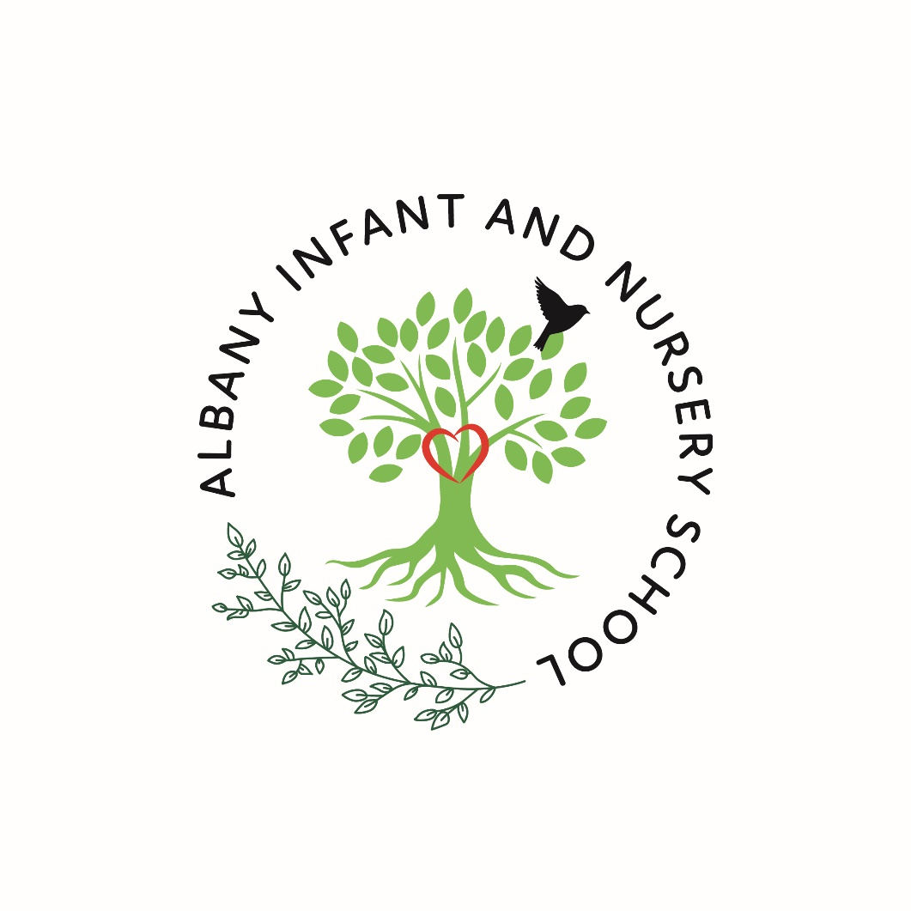

EYFS Handbook
2026/27

There are two things we should give our children, roots to know where they have come from and wings to fly.


Welcome to Albany Infant and Nursery School
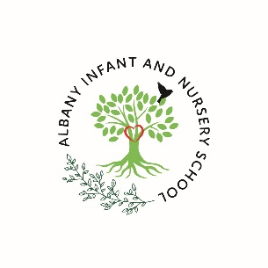

Imagine a school where your child is loved, nurtured and encouraged to be the very best version of themselves. At Albany Infant and Nursery School, we believe in the children we teach. Our updated school logo embodies our vision for our pupils, which is displayed in our main school reception:

There are two things we should give our children:

Roots to know where they have come from and wings to fly.
We have written our curriculum with each and every child in mind. We ensure that our children can see themselves and their family reflected in the books we read and the inspirational people we look up to. It is important to us that our children take pride in their community and heritage and know that they are valued. As an Infant and Nursery School, we take responsibility for ensuring that our children have the confidence, resilience and perseverance to take the next step in their lives, whether that be getting on stage for the first time, moving to a new classroom or leaving us to begin their junior education. We are champions for our children and endeavour to do all we can to help them grow educationally and personally.
Everything we do is underpinned by three very important words:

Safe

Kind

Proud
Our children are taught about these words in terms of themselves, their learning and their environment. These words also underpin our Relationships and Behaviour Policy, where the emphasis is always on relationships first.

When you walk through the doors of Albany Infant and Nursery School, we welcome you into our family. Although our primary role is to provide a world-class education for your child, we are invested in ensuring that, as a family, you have everything you need to thrive.

Albany Infant and Nursery School

Useful Information 2026/2027

School Telephone: 0115 9179212

School Email: office@albany-inf.notts.sch.uk

School Website: www.albanyinfants.co.uk

Head Teacher: Ms K O’Neill
Chair of Governors: Mrs M Greedy

Teaching Staff: Mrs S Hickling (Deputy Head Teacher)
Miss M Shaw (Key Stage One Lead)
Mrs L Matthias (SEND Lead) currently on maternity leave
Mrs P Skivington currently on maternity leave
Mrs S Guadagni
Mrs B Allen
Mrs M Kakar
Miss E Andrew
Mrs J Coales

Teaching Assistants: Mrs C Warner

Mr P Clifton
Mrs D Kaur
Miss A Gregory
Mrs A Mehmet
Mr E Kerry
Miss R Hormell
Miss M Taylor
Mrs S Hufton
Ms L Stokes

Office Staff: Mrs A Long

Mrs S Birley

Midday Supervisors: Miss E Shakh Miss K Lee
Miss J Stephenson Miss A Chamberlain

Caretaker: Mr B McDonald

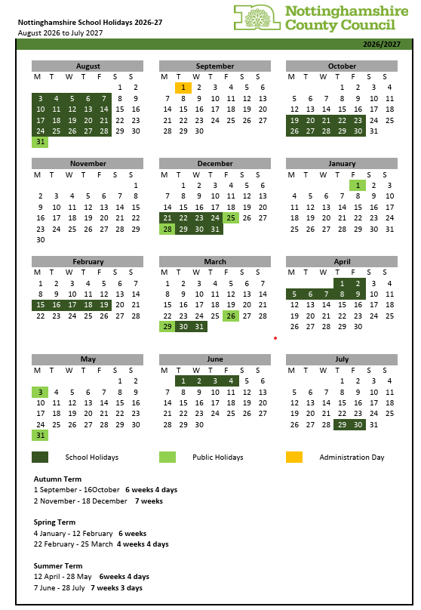

Albany INSET Days 2026/2027
01.09.26, 18.12.26, 22.02.27, 28.05.27, 02.07.27



The Early Years Foundation Stage (EYFS)

EYFS is the Early Years Foundation Stage of education which covers Nursery and Reception classes. The education in EYFS is governed by national standards and guidance as well as a range of documents including:

Statutory framework for the early years foundation stage (publishing.service.gov.uk)

Development Matters - Non-statutory curriculum guidance for the early years foundation stage (publishing.service.gov.uk)

Birth To 5 Matters – Guidance by the sector, for the sector

There are four guiding principles to shape the practice in EYFS.

- every child is a unique child, who is constantly learning and can be resilient, capable, confident and self-assured
- children learn to be strong and independent through positive relationships
- children learn and develop well in enabling environments with teaching and support from adults, who respond to their individual interests and needs, helping them to build their learning over time. Children benefit from a strong partnership between practitioners and parents and/or carers
- importance of learning and development. Children develop and learn at different rates. The framework covers the education and care of all children in early years provision, including children with special educational needs and disabilities (SEND)

At Albany, we believe that the Early Years are vital for our young children. Our children learn through a balance of adult directed – discrete – learning and child-initiated play. We ensure that our environments provide high quality opportunities for our children to explore the world around them and deepen their learning. Our planned experiences open our children’s eyes to the wider world and give them opportunities to develop in knowledge and grow personally.



The Curriculum

Our foundation stage is a calm and tranquil space which is full of exciting education, with pockets of awe and wonder at every turn. Our two Reception classes, Willow Class and Maple Class, share an open plan unit and designated outdoor area. Nursery is based in its own separate building with enclosed grounds for children to explore the outdoor environment.

There are 7 education programmes (previously areas of learning) which are:

Prime Areas:

Communication and Language
Personal, Social and Emotional Development
Physical Development

Specific Areas:

Literacy
Maths
Understanding the World
Expressive Arts and Design

Our curriculum is broad and balanced providing opportunities for indoor and outdoor learning throughout the day. Learning is carefully sequenced from Nursery to Year 2, ensuring that prior learning in the foundation stage builds into the national curriculum learning from Year 1 onwards.

Communication and language
Communication is vital for our young children. This area of learning focuses on understanding, communicating needs with others and building vocabulary. We believe that the number and quality of the conversations children have with adults and peers throughout the day within a language-rich environment is crucial. As such, our staff have been trained in how to deliver quality interactions which move learning forwards.

Personal, social and emotional development
Strong, warm and supportive relationships with adults enable children to learn how to understand their own feelings and those of others. Our children are supported to manage their emotions, develop a positive sense of self, set themselves simple goals, have confidence in their own abilities, to persist and wait for what they want and, direct attention as necessary. We give our children the tools they need to be citizens of the future.

Physical development
Physical activity is vital in children’s all-round development, enabling them to pursue happy, healthy and active lives. At Albany, we are very aware of the benefits of physical development on mental health. Through carefully planned physical education sessions, providing opportunities for play both indoors and outdoors, adults support children to develop their core strength, stability, balance, spatial awareness, co-ordination and agility. Fine motor control, linked to literacy, is developed through a range of activities including dough disco, malleable play and regular handwriting practice in Reception.
Literacy

We consider it our role to foster a lifelong love of reading in our children therefore a reading rich environment is created at Albany. Books feature prominently in our day and around our classrooms. Children are introduced to listening in nursery through environmental sounds, body percussion and rhyme. This is built upon in Reception by the introduction of our synthetic phonic scheme “Little Wandle.” A daily discrete English lesson helps the children apply their phonics to a different stimulus.

Maths
We believe that developing a strong grounding in number is essential so that all children develop the skills, knowledge and confidence to excel mathematically. Daily discrete Maths lessons in Reception using NCETM Mastering Number and White Rose Maths support this. Children are taught to count confidently, develop a deep understanding of the numbers to 10 and beyond, the relationships between them and the patterns within those numbers. We ensure children have frequent opportunities to apply this understanding - such as using manipulatives - children will develop a secure base of knowledge and vocabulary from which mastery of mathematics is built.
Understanding the world
Understanding the world involves giving children experiences which help them to make sense of the physical world and their community. By visiting and revisiting experiences, children’s knowledge and sense of the world around them develops from visiting parks, allotments, libraries and the theatre, to meeting important members of society such as police officers, nurses and firefighters. In addition, introducing a range of texts, stories and rhymes will foster their understanding of our culturally, socially, technologically and ecologically diverse world. As well as building important knowledge, we work hard to widen children’s vocabulary which supports later reading comprehension. To aid the children in making sense of where they are in time and place, understanding the world is a driver subject in all of our three enquiries.

Expressive arts and design
Imagination and creativity are vital to our children. We believe it is important that our children have regular opportunities to engage with the arts, enabling them to explore and play with a wide range of media and materials. The quality and variety of what children see, hear and participate in help develop their self-expression, vocabulary and ability to communicate. Our children are exposed to theatre, dance, drama, music and design and have the opportunity to visit the theatre as well as participate in Christmas and nativity performances.
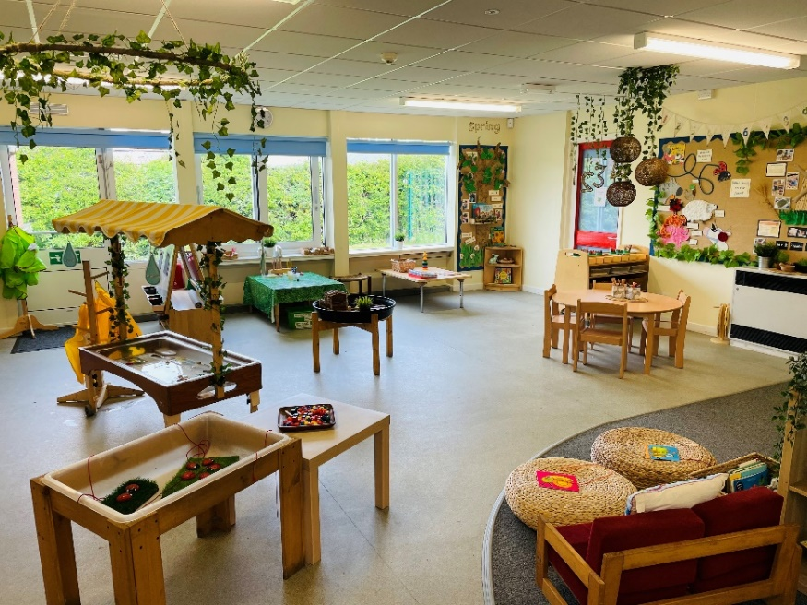

The Nursery – Acorns Class

Nursery Staff

Our nursery is staffed by one teacher – currently Mrs Kakar – and two teaching and learning assistants. School is lucky to have an emotional literacy learning assistant (ELSA) trained in school who spends some of her time in nursery supporting emotions, turn taking and sharing.

Nursery Times

The morning nursery session starts at 8.45am and ends at 11.45am. The afternoon session starts at 12.15pm and ends at 3.15pm. Staff will be on hand to open the gate. Please wait on the pathway outside the nursery building.

Starting Nursery

Your child can join our nursery on the Monday after their third birthday. If you would like to discuss a different start date, our nursery administrator, Mrs Birley, will be happy to help you Monday to Thursday in the school office.

Your Child’s First Day

Starting Nursery or Reception is a big day for you and your child. Lots of children settle in easily once they have visited but some take a little longer and this is quite normal. If your child is reluctant to leave you when they arrive at nursery, you can help them by being confident and positive. The staff will help you by welcoming your child into nursery while you leave. Please don’t worry – your child will usually be happily playing within a few minutes. If this is not the case, nursery staff will help you both by putting together a personalised plan for the beginning of the day.

15- and 30-Hour Provision in Nursery

All children are able to access 15 hours of fully funded nursery sessions from the age of 3. Some families are eligible for 30 hours of free sessions – please visit www.childcarechoices.gov.uk to see if you are eligible and then contact our school office for a form to complete. Each nursery session is 3 hours long and we ask you to choose your preferred pattern of sessions before your child starts with us. We prefer children to attend for either 5 mornings, 5 afternoons or all day. In some circumstances, we can be more flexible with the pattern of sessions but this is dependent on the number of children attending. Where there may be a change in circumstances, we may be able to change the pattern of sessions but we would ask for at least 4-weeks’ notice.

If you are not eligible for 30 hours of free sessions, your child is welcome to attend for additional sessions at the cost of £12.50 per session. Where payments are required, you are asked to complete a nursery contract form and you will be invoiced every half term. Payments must be made in advance or the school may cancel the sessions if payment is not made. Our office staff are always willing to discuss this if there are any issues which may occur.

Lunch at Albany Infant and Nursery School
Lunch in Nursery

Children who attend nursery all day are able to stay with us for lunch. Children should bring their own packed lunch and will be supervised by school staff, eating together and then continuing to learn and play once they have finished. If your child brings a packed lunch, as a healthy school we do ask that the food should be healthy and not contain foods such as biscuits, sweets and crisps. We would also ask that you do not send your child with nut-based products due to some children having severe allergies. Water is provided. All packed lunches should be in a secure and clearly named container.

Lunch in Reception

All children in infant schools (Reception, Year 1 and Year 2) are entitled to universal free school meals. A hot lunch will be provided, cooked on site from our catering team, coordinated by Vertas. Menus will be shared on Class Dojo so that you can choose the days you think your child will enjoy lunch. Some children may prefer a packed lunch from home. If your child brings a packed lunch, as a healthy school we do ask that the food should be healthy and not contain foods such as biscuits, sweets and crisps. We would also ask that you do not send your child with nut-based products due to some children having severe allergies. Water is provided. All packed lunches should be in a secure and clearly named container.

Reception – Willow and Maple class

Reception staff

Our two Reception Classes are part of an open plan wing in the main school building. Currently, each class has one teacher and these are supported by three teaching and learning assistants. The staff work together to ensure that both indoor and outdoor provision is accessible throughout the day and appropriately supervised.

The school day

The school day begins with a soft start from 8:40 – 8:55am and ends at 3:20pm.

An example Reception timetable

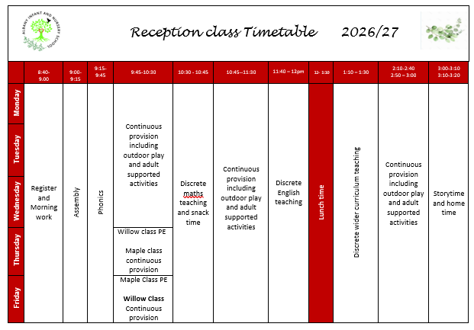

Reading at Albany

Reading is an important life skill, as such it has a high priority at Albany. Children will have multiple opportunities throughout the day to interact with stories. Each classroom has a story area and every day ends with a story. To add to this, children visit our school library and take home their choice of text.

Our aim is to ensure that every child has access to high quality texts, therefore our curriculum ensures that children access texts from a variety of countries, backgrounds and authors. As part of our curriculum offer, children join our local library and visit termly to immerse themselves in a world of reading.

Learning to read

We carefully assess the starting points for children’s reading and match them to a decodable reading book which is closely linked to our chosen phonics scheme, Little Wandle. Children bring this book home as well as a book that they have chosen to read for pleasure.

At Albany, we have a dedicated reading session three times per week where children become more fluent with a text, becoming expert readers using expression and comprehension skills to fully understand the characters, setting and story, as well as decode the text confidently. These sessions are lead by a teacher or teaching assistant in small groups.

Attendance

Although under 5s do not fall under the same guidelines as those in the later years, it is important to begin to build those good routines in preparation for Reception and beyond. It is really important that children have a good routine to begin with, especially if they are upset or nervous about being away from you. We regularly monitor the attendance of all of our children and will notify parents where we have concerns.

Absence

We appreciate that all children fall ill from time to time and need to have a day or two away from school. Please let us know that your child will not be attending due to illness by 9:15am on the first day and any consecutive days of absence on the school telephone number: 01159 179212. You can also leave a message on our telephone system.

Wherever possible, we ask you to take your holidays during school breaks. Schools are not allowed to authorised holidays unless there are exceptional circumstances. Children feel more settled at school through regular attendance. Their wellbeing is the most important factor in learning and progressing.

Communication

We aim to promote an ‘open door’ approach here at Albany Infant and Nursery School and welcome parents and carers into our school and nursery. You can always speak to teachers or teaching assistants briefly at the start or end of each day. We communicate school information via Class Dojo which you will be invited to join should you choose us for your child’s educational journey. Class Dojo allows you to contact school staff directly – including the headteacher. We ask that you do not use Dojo to inform of absence. We will also aim to update our website as regularly as possible.

Should you ever have a query or concern your first port of call should be your child’s teacher. Our office staff are also able to help you with generic aspects of school life e.g., dates, times etc. Should your query or concern be of a more personal nature, or if you feel that you have not been able to resolve something, then the senior leadership team are here to help and support you.

We will soon get to know you and staff will recognise whoever collects your child at the end of the school day. We will never let a child go home with someone that we do not recognise or if you have not informed us of this. Please always contact us if someone different is collecting your child. If this is someone we have not met before, we will ask you to provide us with a password which we would expect this person to know on collection at the end of the day.

There may be occasions where we need to contact you (for example, if your child is ill during the session). Please ensure that your contact details are kept up to date – this can be done through our school office. Being able to contact you promptly can save your child unnecessary distress.

Medicines in EYFS

We are happy to help with medication and can administer medicines that have been prescribed by a doctor throughout the day. In some circumstances, we are also able to administer non-prescribed medicines such as Calpol where this will support a child suffering with symptoms which can be easily relieved and would otherwise prevent them from being at school. Please take the medicine and instructions to the office. You will be asked to sign an authorisation form and staff will be happy to help you.

Money and Charges

Occasionally we may ask for voluntary contributions towards activities such as trips and extra-curricular activities. This is in line with our charging policy which is available on our website. Payments can be made through our online payment system, ParentPay. This can be found at www.parentpay.com On the home page, select the parent login option and this will send you to a page where you need to enter the user name and password supplied on your activation letter. There is also an app available which can be downloaded on IOS or Android. ParentPay is our system for paying for school trips, wraparound care and any other school related charges.

Data Protection

We request personal data from you with regards to your child and yourself. This includes contact details and medical information. We ensure that all data is held securely, remains private and dealt with sensitively. The General Data Protection Regulations (GDPR) came into effect in 2018 and our school fully complies with information legislation. As part of this, we have a designated Data Protection Officer (DPO), Miss G Frost, whose role it is to ensure that we remain GDPR compliant. You can contact our DPO by emailing dpo@albany-jun.sch.uk. Our office staff will also be willing to help you should you have any queries or concerns. A copy of our Privacy Notice and other related documents can be found on our website.

Early Years Pupil Premium Funding

The Government currently provide additional funding to our school and nursery for each pupil that is eligible for the Early Years Pupil Premium. This funding enables us to provide additional support for your child’s learning, equipment, and activities. When a child reaches junior school, they will also receive a free school meal (which all infant aged children are currently entitled to regardless of eligibility for the Pupil Premium). To ensure that we receive this additional funding for your child, we ask that parents who qualify take up their entitlement to the Early Years Pupil Premium. Eligibility criteria and details on how to apply are below:

Your child’s school may qualify for the Early Years Pupil Premium if your child attends a Nottinghamshire County Council School or Nursery and you receive one of the following benefits:
- income support
- income based jobseeker’s allowance
- income related employment support allowance
- support under Part VI of the Immigration and Asylum Act 1999
- child tax credit, provided you are not entitled to working tax credit and have an annual income
- assessed by HM Revenue & Customs) that does not exceed £16,190
- guarantee element of state pension credit

You can apply for the Early Years Pupil Premium by visiting our school office. Equally, office staff will support your transition to Pupil Premium when your child enters Reception.

Healthy Living

As part of our healthy living programme, we provide children with a water bottle. This should be taken home each day, washed, refilled and returned to school the next day. We teach children the importance of eating healthy food and food preparation skills. Fruit is provided every day for every child – children usually eat this when listening to a story or with their milk. Albany Infant and Nursery School takes its responsibility seriously to safeguard our pupils with any allergy including a food related allergy. As a result, we are a nut free school to support the wellbeing of our pupils and staff.

Cool Milk

All children under the age of 5 are entitled to free milk under the Cool Milk scheme. Please see the Cool Milk leaflet included in your pack for further information or go online at www.coolmilk.com Once your child turns 5 they can still have milk for a small fee paid directly to Cool Milk.

Safeguarding and Pastoral Support

The safeguarding of our children is of paramount importance to us here at Albany Infant and Nursery School. We have a duty to ensure that our children are protected from all forms of abuse and to act on any concerns that may arise about the safety or wellbeing of a child. All of our staff are trained in child protection and safeguarding and aim to ensure that our children are taught in a safe and nurturing environment.

In school, we have four designated safeguarding leads (DSLs) who have the responsibility to ensure that any safeguarding concerns are acted on. This may involve talking to parents or liaising with outside agencies. Our DSLs are Ms O’Neill (Head Teacher), Mrs S Hickling, (Deputy Head Teacher), Ms Shaw (KS1 Lead). Additionally, we have Mrs Mehmet, our school ELSA and trained mental health lead. Please contact one of our DSLs if you have any concerns about a child - safeguarding is the responsibility of us all.

Mrs Mehmet, mentioned above, is our school ELSA (Emotional Literacy Support Assistant). Mrs Mehmet is able to support children in school with a range of pastoral issues such as self-esteem, confidence and friendships. This is achieved through nurture groups and 1-1 sessions which are held during the school day.

Mrs Mehmet is also able to support families with wider issues such as behaviour at home, bereavement and separation. You can always arrange to meet with Mrs Mehmet by making an appointment through the main school office or you can email her directly on elsa@albany-inf.notts.sch.uk Please do contact us if ever you or your child have a problem that we can help with.

Uniform
At Albany Infant and Nursery School our school logo and uniform connect us. By wearing our school colours of red, white and grey we feel part of something special – a family. Our logo helps us to think about where we have come from, our roots, and the uniqueness of who we are. The bird reminds us that with perseverance and resilience we have the ability to fly.

A range of items can be purchased from Simply First (Mark Street Industrial Estate, Sandiacre). https://www.schooluniformnottingham.co.uk Most of the large supermarkets also stock school clothing.

Boys Girls

White shirt or polo shirt White blouse or polo shirt
Red jumper or sweatshirt Red cardigan, jumper or sweatshirt
Grey trousers or shorts Grey skirt, pinafore dress or trousers
White/grey/black socks White/grey/black tights or socks
Red/white gingham dress
Black shoes Black shoes
Red bookbag Red bookbag

Children should also be provided with a warm waterproof coat for winter or a sunhat for summer.

Our Nursery children are welcome to wear or uniform or their own comfy clothes.
In Reception, we ask that all children wear our uniform with pride.

PE kit

As the children have two hours of PE timetabled each week from Reception and will be engaged in physical activities across school, we would ask that all children have a PE kit to stay in school in a red drawstring bag. This should consist of a white t-shirt, black shorts and correctly fitting plimsols.

IMPORTANT: Please ensure that all clothing is clearly marked with your child’s name

We have protective clothing available for messy activities. If you are able to provide your child with wellies, puddle suits, or a change of clothing for OPAL play this would be helpful so that they can experience all that OPAL has to offer.

It helps us to encourage independence if the children have clothes with easy fastenings which they can do themselves. Sometimes the children need to take their shoes on and off so please avoid tricky laces or buckles. We also encourage children to use the toilet independently but if this is an area you are finding challenging, please let us know so we can support you.

As the children spend a lot of time engaged in physical activities in our outdoor area, jewellery is not suitable.

Hair

If your child’s hair is shoulder length or longer it must be tied up. Red or red/white hair accessories help us to be in school uniform.

Exemptions to uniform

If your child requires to wear any headwear or jewellery for religious purposes / observations please let us know. Equally if your child has extreme sensory need, please inform your child’s teacher or the school office team. Reasonable adjustments to uniform will always be considered in this case.







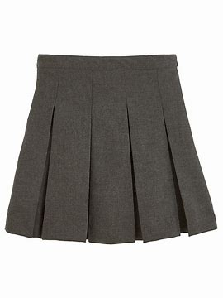

Helping in School

We welcome parental help at school. If you have some spare time and would like to volunteer, please see your child’s teacher. Parents may help out with baking, reading, trips and other class activities. For safeguarding reasons, we ask all regular volunteers to undertake a DBS (disclosure and barring service) check – the school will organise this for you.

Albany Helping Hands

The Albany Helping Hands group is made up of parents who volunteer to help with the planning and organising of fundraising events, including helping out on the day of the event. Events include discos, film nights and selling refreshments at school events.

The group is currently looking for new members, all parents are welcome to attend meetings which are held at school – dates and times of meetings are shared through Class Dojo and our school notice board. The funds raised are managed by the group and are used to purchase new resources or external providers of curriculum activities for the school and nursery. This really does depend on the support and help of our parent body so please do get involved if you are able to. This year AHH have raised £2000 and contributed funds to enable changes to our playground, subsidised school trips and for the upgrade of our school library.

School Governors
School governors are volunteers who help to lead the school, providing support and challenge for the leadership team and overseeing compliance. They are involved in decisions about all aspects of managing the school – such as maintaining buildings and running budgets, supporting staff and setting standards of school discipline. Governors also help to make big decisions about the school’s long-term vision. They support the Head Teacher, but also ask questions and make sure the Head Teacher is taking the school in the right direction. A number of parents are elected to the governing body and we advertise vacancies as they arise. Please speak to a member of the school leadership team should you like to become involved with our governing body.

Parent Support
We believe that education is a partnership and we aim to work closely with you to ensure we offer your child the very best. Staff are very approachable so please feel free to talk to us if you have any questions or concerns or just want to share a special time or celebrate a success! We will aim to invite you into school as often as possible. Staff will also send home a document each term which shows how your child is progressing within the key areas of learning.

There are many ways that you can support your child at home:

- Read books with your child regularly
- Talk to your child about what they have done at school and listen to what they have to tell you
- Help your child to be independent – help them to learn how to change their clothes and tie their own laces if their shoes have laces
- Read, share and tell stories
- Count together – steps, socks in 2s, toys and shopping as you put it away. Count money and practice telling the time
- Play board games and help children to take turns
- Provide writing resources for children to play with at home (coloured pens and pencils, paper, colouring books etc)

Parking

We understand that this is not always possible to walk to school and parents/carers sometimes need to use their car. We are very concerned about the safety of children as they arrive at, and leave the site. Please park very carefully, avoiding the zig zag lines and the corners of Churchill Drive and Hickings Lane where other parents and children need a clear view to be able to cross the road safely. We ask that you are mindful of our neighbours. Community police regularly patrol during busy times to ensure safe and legal parking around schools.

Healthy and Safety including Mobile Phones

For health and safety reasons, dogs are not allowed on the site unless they are guide dogs or for other therapeutic reasons. We politely ask that when children / adults arrive on site, they dismount from scooters/bikes due to high volumes of people moving around.

Our school site is also a no-smoking area. This includes the use of e-cigarettes.

The school has a mobile phone policy which aims to promote safe and appropriate practice through establishing clear use guidelines. It is the school’s duty to have effective safeguarding practice and protection in place for all.

Wraparound care

We have an inhouse Breakfast Club, sessions start at 7.30am and cost £5.50. We do not currently have an after school club but hope to in the future. Both infant and junior children are welcome at our clubs and will be dropped off by our caring staff. There are 8 Nursery spaces available at each club. Bookings should be made via your child’s ParentPay account.

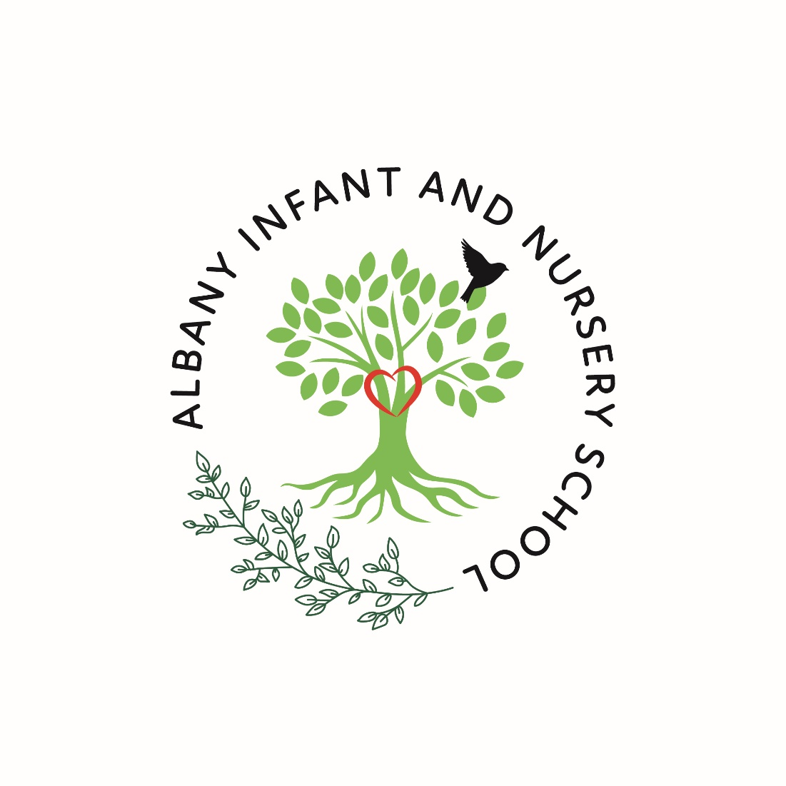
Albany infant and Nursery School
Grenville drive
Stapleford
Nottingham
NG9 8PD

01159179212

