Albany Infant and Nursery School

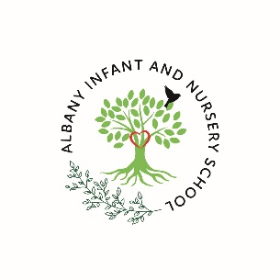

Key Stage One
Handbook 2026/2027

There are two things we should give our children, roots to know where they have come from and wings to fly.



Welcome to Albany Infant and Nursery School

As the proud Head Teacher of Albany Infant and Nursery School I would like to begin by welcoming you to our amazing school. We are a “Good “school who have the honour and privilege of serving the community of Stapleford. Our aim is to ensure that all children are safe, happy and receive a world class education. As a result, we strive for excellence in all that we do. All of the adults in our school hold ambition for our pupils and their families; aiming towards giving children the best possible quality of teaching and learning, excellent opportunities to experience the world around them and providing our children with role models to help them on their journey to becoming global citizens of the future. We are passionate about teaching and learning and aim high each and every day.

We care deeply about our school and our children so LOVE filters through everything we do. Learning is at our core. Everyone at Albany considers themselves a learner. This means that we constantly strive for excellence for our children and ourselves as educators. We carefully plan the Opportunities that our children have whether this is taking them to the theatre, enjoying a snow disco or exploring the wider world. Each experience is carefully woven into our curriculum so that our children deepen their understanding and build on their prior knowledge. Our Values ensure that we challenge children to be the best they can be, demonstrating resilience to achieve their academic and personal goals. By promoting Excellence in all that we do, we inspire our children to want to learn and ensure that we prepare them for the next step in their journey.


Albany is a very special place where you can be sure of a warm welcome.

Albany Infant and Nursery School

Useful Information 2025/2026

School Telephone: 0115 9179212

School Email: office@albany-inf.notts.sch.uk

School Website: www.albanyinfants.co.uk

Head Teacher: Ms K O’Neill
Chair of Governors: Mrs M Greedy

Teaching Staff: Mrs S Hickling (Deputy Head Teacher)
Ms M Shaw (KS1 Lead)
Mrs L Matthias (SEND Lead) currently on maternity leave
Miss E Andrew
Mrs P Skivington currently on maternity leave
Mrs S Guadagni
Mrs B Allen
Mrs Kakar
Mrs J Coales

Teaching Assistants: Mrs C Warner

Mr P Clifton
Mrs S Hufton
Miss A Gregory
Mrs A Mehmet (ELSA)
Mr E Kerry
Miss M Taylor
Miss R Hormell
Mrs D Kaur
Ms L Stokes

Office Staff: Mrs A Long

Mrs S Birley

Midday Supervisors: Miss K Lee Miss E Shakh
Miss J Stephenson Miss A Chamberlain

Caretaker: Mr B McDonald

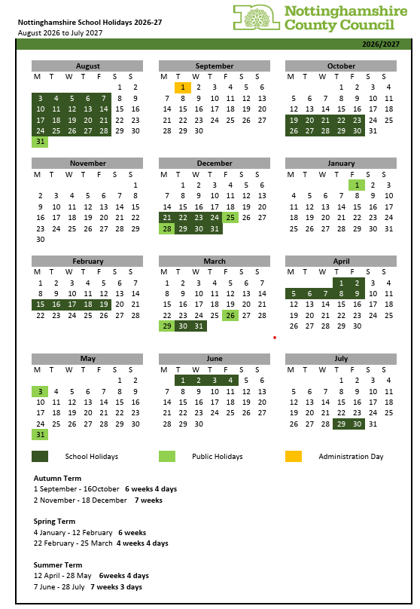

Albany INSET Days 2026/2027

1st September 2026, 18th December 2026, 22nd February 2027, 28th May 2027, 2nd July 2027.


The Key Stage One Curriculum (KS1)

The term Key Stage One refers to school years One and Two and aims to build upon the Early Years Foundation Stage of education, which at Albany is covered within its Nursery and Reception classes. The education within KS1 and the objectives taught are outlined within the National curriculum of England and can be accessed via the link below.

The national curriculum in England - Framework document (publishing.service.gov.uk)

Whilst the National curriculum outlines the statutory objectives that must be taught within KS1, at Albany we have carefully sequenced and adapted the content of our curriculum to cater for the needs of the community and families we serve.

As we do in all areas of our school, we have high expectations and aspirations for our children within KS1 and work hard to support them to achieve their full potential as they gain the ability to understand the world around them. Our focus is on nurturing creative, resilient and independent learners who feel excited and confident to take on new challenges as they develop a real lifelong love of learning.

Within KS1, a greater emphasis is placed upon establishing productive and supportive learning behaviours to support independence within our children as they transition into a different phase of their learning journey. This transition between key stages sees the curriculum move away from the seven areas of learning within the Early Years Foundation Stage (EYFS) to a more subject specific curriculum delivered across Key Stage One and Two.

At Albany, we believe that Years One and Two are vital years in shaping our young children’s attitudes towards learning and education. It is because of this; we take great pride in providing our children with a wide range of planned experiences to open our children’s eyes to the wider world and give them opportunities to develop in knowledge and to grow personally as an individual. We aim for our curriculum to show the children the WORLD.

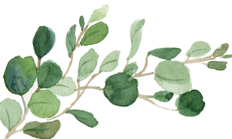

The Curriculum

Our approach to teaching and learning within the Key Stage One curriculum is informed by the best available research and evidence on child development for children aged between five and seven. We aim to provide a learning experience that reflects the broad range of skills, knowledge and understanding that children need as foundations to build a successful future upon. We carefully guide and support our children throughout this key stage to ensure that by the time they reach the end of Key Stage One our children are suitably prepared to embrace the opportunities that lie ahead of them as they progress into the final stages of their primary education.

The Key Stage One Curriculum:

The KS1 curriculum consists of compulsory subjects that are categorised as both core and foundation subjects. Below you will find an outline of each curriculum subject that is delivered here at Albany.
The Core Subjects:
- English
- Maths
- Science
English:
Key stage One focuses on developing the children’s capabilities and confidence in spoken language, reading, writing and vocabulary. We continue to build upon the love of reading established with in the early years by offering access to a rich variety of fiction and non – fiction texts which ensures the development of fluency. We focus on increasing the awareness our children have of writing for purpose and expose our children to a wide range of writing genres, including narratives, explanations, descriptions and poetry. Our environments continue to be language rich and act as a scaffold to support the children with their vocabulary and language development as they seek to develop their writing.
Phonics:
In Key Stage One, children continue to participate in adult lead synthetic phonic sessions as they progress through the Little Wandle phonics program. They begin to focus even more on alternative ways of making sounds and begin to consider how to transfer ‘best bet’ spelling rules into their writing. We aim for all children to have completed all the sounds covered by the Little Wandle phonic program by the end of Year One and to consolidate their understanding in Year Two. At the end of Year One children will be required to sit a Phonic Screening check to assess their progress against national expectations, to find out more about what this will mean for your child please visit.
Phonics screening check: information for parents - GOV.UK (www.gov.uk)

For more information on the Little Wandle Synthetic Phonics program please visit:
For parents | Letters and Sounds (littlewandlelettersandsounds.org.uk)

Reading:
We carefully assess the starting points for children’s reading and match them to a decodable reading book which is closely linked to our chosen phonics scheme. Children bring this book home as well as a book that they have chosen to read for pleasure.

At Albany, we have a dedicated whole class reading session every day where children become more fluent with a text, becoming expert readers using expression and comprehension skills to fully understand the characters, setting and story.

Handwriting:
Our children continue to be supported to build upon the handwriting skills that they have been taught within the Early Years. Children are encouraged to perfect the tripod grip for handwriting provided they are developmentally and physically able to do so. As the children move through KS1 they experience five dedicated- adult lead handwriting sessions where they learn to initially print letters before progressing to cursive handwriting as we aim to build fluency and stamina within our young writers.

Maths:
Mathematics at Albany is guided by White Rose Maths we follow an adapted version of the White Rose Maths curriculum and utilise White Rose resources to support our teaching and assessment of mathematics.

The White Rose Maths scheme provides children with a range of fluency, problem solving and reasoning throughout different blocks of learning whilst incorporating and supporting the delivery of the mathematics via the mastery principles. Guiding children through the use of concrete resources, pictorial images and finally abstract calculation methods to support their understanding of new concepts.

Science:
In Key stage One, Science aims to build upon the scientific knowledge the children have gained throughout the early years. We place great attention on enabling our children to explore both the natural and manmade world around them through scientific enquiry.

Our science curriculum inspires our children to become the scientists of the future as it prompts curiosity, encourages children to question and allows them opportunities for first hand experience of experiments and scientific investigations as they develop a greater understanding of the subject.

The Foundation Subjects:
- Art
- Design and Technology
- Geography
- History
- Physical Education (PE)
- Religious Education (RE)
- Computing
- Music

Art:
High emphasis is placed upon the arts with Key Stage One as we see the ability to appreciate art as one of the many languages of learning. We aim to engage and inspire pupils to experiment, invent and create their own individualized works of art whilst developing their understanding of the role that art and design have shaped our history and continues to contribute to the culture, creativity and wealth of our nation. Where appropriate, links are also made to ensure that a child’s social, moral, spiritual and cultural development is enhanced through art.
Throughout our art curriculum we explore:
- some of the world’s great artists.
- vocabulary linked to the area of work.
- a range of techniques, including drawing, painting and sculpture.
- applying these techniques to produce their own creative works.
- evaluating and thinking critically of their own and others work.

Design and Technology:
Within design and technology, we encourage children to use creativity and imagination to design and make products that solve problems within a variety of contexts, considering their own and others’ needs, wants and values. We aim to achieve this by teaching knowledge and skills through high quality sequences of lessons, which are designed to help pupils develop their understanding of:
- the origins of the project, often in the form of a problem to solve, focusing on the appropriate technical vocabulary.
- products and models already available, considering their design elements included and the technology used.
- drafting and designing their own model by drawing annotated sketches, creating prototypes and modifying when necessary.
- equipment and tools necessary to complete the project as well as the safety aspects involved.
- making the model, following their design and adapting when needed
- evaluating their work critically and that of others

Geography:
In Geography, our curriculum inspires a curiosity and fascination within our children about the world and its people. It does this by teaching about diverse places and people, considering natural and human environments together whilst developing a deep understanding of the Earth’s key physical and human processes as we strive to help our children to understand what it means to be a ‘geographer’.
We achieve this by teaching knowledge and skills through high quality sequences of lessons which are designed to help pupils develop their understanding of:
- The location of a locality;
- The human and physical features of the locality;
- Who lives in the locality and what life is like;
- How the locality compares to our locality;
- The environmental issues facing the locality based on physical and human geography.
History:
At Albany we place great importance on the study of history in our curriculum as it is the greatest vehicle that we can use to help our children better understand the present.
Our curriculum journey explores the past and recognise the impact that it has had on our lives today through the study of:
- When different periods of history occurred in relation to their lives and the lives of their families (chronology);
- What everyday life was like for people living during different periods of time through use of artefacts and practical, real-life experiences (comparing and contrasting);
- Key events and significant people and how these have affected our lives today (influence and impact);
- The similarities and differences between different periods of history and then and now, making use of key vocabulary (comparing and contrasting);
- How historical evidence is gathered and examined, thinking critically about reliability, in order to draw their own conclusions.
Physical Education:
Physical education at Albany is taught by a combination of class teachers and PE specialists and has been sequenced using the Complete PE teaching programme. Children experience two hours of high-quality PE each week and through exposure to fundamental movements become confident and competent in applying their skills of balance, agility and coordination to a range of sporting activities.

The curriculum facilitates opportunities for competition (both against self and others) in a range of challenging situations. Children are taught to master basic movements such as running, jumping, throwing and catching in isolation before applying these skills to team game situations. Children also take part in gymnastic sessions in which they create and perform sequences using simple movement patterns.

Religious Education:
The Religious Education curriculum at Albany is planned in line with the Nottinghamshire Agreed Syllabus and is supported by other resources. We aim to develop an increasing understanding of wide areas of RE subject knowledge, and children’s religious literacy via thought provoking, philosophical enquiries around religion and the world.

Our curriculum provokes our children to ask challenging questions across a range of themes, as we teach them about views on the meaning and purpose in life, beliefs about God, ultimate reality, issues of right and wrong and what it means to be human.

Computing
At Albany we believe that a high-quality computing education should equip children with the skills to thrive in a world that is becoming more dependent upon technology. Therefore, our curriculum provides our children with the opportunities to use computational thinking and creativity to help them to understand and change the world.

The core of computing is computer science, in which pupils are taught the principles of information and computation, how digital systems work, and how to put this knowledge to use through programming. Building on this knowledge and understanding, pupils are equipped to use information technology to create programs, systems and a range of content.

The teaching of computing at Albany also ensures that pupils become digitally literate, meaning that by the end of KS1 children able to use, and express themselves and develop their ideas through, information and communication technology – at a level suitable for the future workplace and as active participants in a digital world.

Alongside teaching the skills of computing through our curriculum delivery, we teach the importance of staying safe online to our children. Using ‘Education for a connected world’ we explore internet safety ensuring that our children know the importance of password protection, can identify how to safe online and know when to report concerning online actions to an adult.

Music
Music at Albany is taught by a combination of class teachers and our in-house music specialist. We aim to encourage pupils to develop a love of music and to embrace their talents as musicians and singers.
Our curriculum has been designed to provide opportunities for our children to:
- perform, listen to, review and evaluate music across a range of historical periods, genres, styles and traditions.
- listen to and evaluate the works of the great composers and musicians.
- sing and using their voices to create and compose music on their own and with others.
- play tuned and non-tuned instruments.
- use technology appropriately where possible.
- Understand how music is created, produced and communicated using pitch, duration, dynamics, tempo, timbre (tone), texture, structure and appropriate musical notations.

Our Music curriculum is guided by the charanga scheme of learning.

Key Stage One – Oak, Elm and Beech class

Key Stage One staff

Our three Key Stage One classes are part of an open plan wing in the main school building. Currently, each class has one teacher and access to three teaching and learning assistants. The staff work together to ensure that adult support is available to those who need it to ensure that every child is provided with effective scaffolds to allow them to feel success at every opportunity.

The school day

The school day begins with soft start from 8:40am and ends at 3:20pm.

An example KS1 timetable

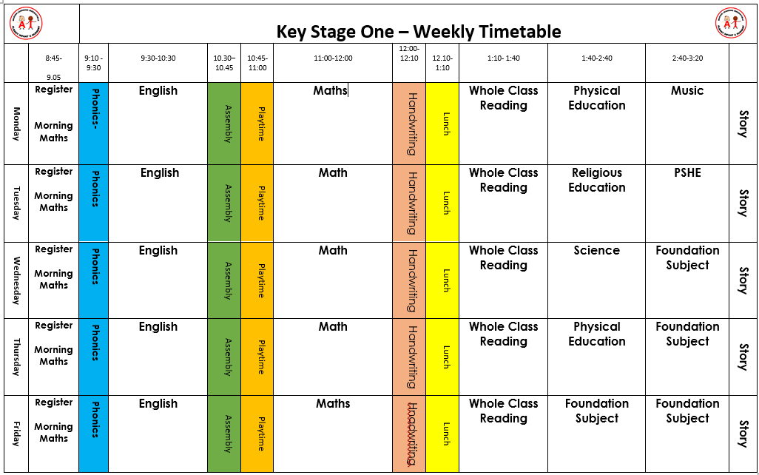

Reading is an important life skill, as such it has a high priority at Albany. Children will have multiple opportunities throughout the day to interact with stories. Each classroom has a story area and every day ends with a story. To add to this, children visit our school library and take home their choice of text.

Our aim is to ensure that every child has access to high quality texts therefore our curriculum ensures that children access texts from a variety of countries, backgrounds and authors. As part of our curriculum offer, children join our local library and visit to immerse themselves in a world of reading.

Learning to read

Attendance

We regularly monitor the attendance of all of our children and will notify parents where we have concerns.

Absence

We appreciate that all children fall ill from time to time and need to have a day or two away from school. On the first day of absence please let us know by phone call as soon as possible on 01159 179212 – you can leave a message on our telephone system. Please contact us by 9.15am.

Wherever possible, we ask you to take your holidays during school breaks. Children feel more settled at school through regular attendance. Their wellbeing is the most important factor in learning and progressing.

Communication

We aim to promote an ‘open door’ approach here at Albany Infant and Nursery School and welcome parents and carers into our school and nursery. You can always speak to teachers or teaching assistants briefly at the start or end of each day. We communicate school information via Class Dojo which you will be invited to join should you choose us for your child’s educational journey. Class Dojo allows you to contact school staff directly – including the headteacher. We do ask that you do not use Dojo to inform of absence. We will aim to update our website as regularly as possible.

Should you ever have a query or concern your first port of call should be your child’s teacher. Our office staff are also able to help you with generic aspects of school life e.g. dates, times etc. Should your query or concern be of a more personal nature, or if you feel that you have not been able to resolve something, then the senior leadership team are there to help and support you.

We will soon get to know you and staff will recognise whoever collects your child at the end of the school day. We will never let a child go home with someone that we do not recognise or if you have not informed us of this. Please always contact us if someone different is collecting your child. If this is someone we have not met before, we will ask you to provide us with a password which we would expect this person to know on collection at the end of the day.

There may be occasions where we need to contact you (for example, if your child is ill during the session). Please ensure that your contact details are kept up to date – this can be done through our school office. Being able to contact you promptly can save your child unnecessary distress.

Medicines in School

We are happy to help with medication and can administer medicines that have been prescribed by a doctor throughout the day.

In some circumstances, we are also able to administer non-prescribed medicines such as Calpol where this will support a child suffering with symptoms which can be easily relieved and would otherwise prevent them from being at school. Please take the medicine and instructions to the office. You will be asked to sign an authorisation form and staff will be happy to help you.

Data Protection

We request personal data from you with regards to your child and yourself. This includes contact details and medical information. We ensure that all data is held securely, remains private and dealt with sensitively. The General Data Protection Regulations (GDPR) came into effect in 2018 and our school fully complies with information legislation. As part of this, we have a designated Data Protection Officer (DPO), Miss G Frost, whose role it is to ensure that we remain GDPR compliant. You can contact our DPO by emailing dpo@albany-jun.sch.uk. Our office staff will also be willing to help you should you have any queries or concerns.

A copy of our Privacy Notice and other related documents can be found on our website.

Money and Charges

Occasionally we may ask for voluntary contributions towards activities such as trips and extra-curricular activities. This is in line with our charging policy which is available on our website. Payments can be made through our online payment system, SchoolMoney. This can be found at www.eduspot.co.uk – you then click on the sign in button in the top right hand corner. In the drop down menu, select the SchoolMoney parent login option and this will send you through to a page where you need to enter your mobile number and email address. Once your child has been admitted, you will be issued with a password which you will also need to enter.

Cool Milk

All children over the age of 5 are entitled to milk under the Cool Milk scheme , please apply at www.coolmilk.com

Pupil Premium Funding

The Government currently provide additional funding to our school and nursery for each pupil that is eligible for the Pupil Premium funding. This funding enables us to provide additional support for your child’s learning, equipment, and activities. When a child reaches junior school, they will also receive a free school meal (which all infant aged children are currently entitled to regardless of eligibility for the Pupil Premium). To ensure that we receive this additional funding for your child, we ask that parents who qualify take up their entitlement to the Pupil Premium. Eligibility criteria and details on how to apply are below:

Your child’s school may qualify for the Pupil Premium Funding if your child attends a Nottinghamshire County Council School or Nursery and you receive one of the following benefits:
- income support
- income based jobseeker’s allowance
- income related employment support allowance
- support under Part VI of the Immigration and Asylum Act 1999
- child tax credit, provided you are not entitled to working tax credit and have an annual income
- assessed by HM Revenue & Customs) that does not exceed £16,190
- guarantee element of state pension credit

You can apply for the Pupil Premium Funding by visiting our school office. Equally, office staff will support your transition to Pupil Premium when your child enters Reception.

Healthy Living

As part of our healthy living programme, we provide children with a water bottle. This should be taken home each day, washed, refilled and returned to nursery the next day. We also run baking sessions through which we teach children the importance of eating healthy food and food preparation skills. Fruit is also provided every day for every child – children usually eat this when listening to a story or with their milk.

Safeguarding and Pastoral Support

The safeguarding of our children is of paramount importance to us here at Albany Infant and Nursery School. We have a duty to ensure that our children are protected from all forms of abuse and to act on any concerns that may arise about the safety or wellbeing of a child. All of our staff are trained in child protection and safeguarding and aim to ensure that our children are taught in a safe and nurturing environment.

In school, we have three designated safeguarding leads (DSLs) who have the responsibility to ensure that any safeguarding concerns are acted on. This may involve talking to parents or liaising with outside agencies. Our DSLs are Ms O’Neill (head teacher), Mrs S Hickling, (deputy head teacher), Ms Shaw (KS1 Lead). Additionally, we have Mrs Harris in Beech class. Please contact one of our DSLs if you have any concerns about a child - safeguarding is the responsibility of us all.

Mrs Mehmet is our school ELSA (emotional literacy support assistant). Mrs Mehmet is able to support children in school with a range of pastoral issues such as self-esteem, confidence and friendships. This is achieved through nurture groups and 1-1 sessions which are held during the school day.

Mrs Mehmet is also able to support families with wider issues such as behaviour at home, bereavement and separation. You can always arrange to meet with Mrs Mehmet by making an appointment through the main school office or she is usually available to talk at the start of each day on the playground. Please do contact us if ever you or your child have a problem that we can help with.

Uniform

At Albany Infant and Nursery School our school logo and uniform connect us. By wearing our school colours of red, white and grey we feel part of something special – a family. Our logo helps us to think about where we have come from, our roots, and the uniqueness of who we are. The bird reminds us that with perseverance and resilience we have the ability to fly.

A range of items can be purchased from Simply First (Mark Street Industrial Estate, Sandiacre). https://www.schooluniformnottingham.co.uk Most of the large supermarkets also stock school clothing.

Boys Girls

White shirt or polo shirt White blouse or polo shirt
Red jumper or sweatshirt Red cardigan, jumper or sweatshirt
Grey trousers or shorts Grey skirt, pinafore dress or trousers
White/grey/black socks White/grey/black tights or socks
Red/white gingham dress
Black shoes Black shoes
Red bookbag Red bookbag

Children should also be provided with a warm waterproof coat. During the summer, please ensure your child has a sunhat.

PE kit

As the children have two hours of PE timetabled each week and will be engaged in physical activities across school, we would ask that all children have a PE kit to stay in school in a red drawstring bag. This should consist of a white t-shirt, black shorts and correctly fitting plimsols.

IMPORTANT: Please ensure that all clothing is clearly marked with your child’s name

Jewellery

We do not allow children to wear jewellery to school for health and safety reasons. However, if your child already has pierced ears they may wear small plain stud earrings. These must be removed by your child at school or at home for PE sessions (Local authority statutory requirement for schools).

Hair

If your child’s hair is shoulder length or longer it must be tied up. Red or red/white hair accessories help us to be in school uniform.

Exemptions to uniform

If your child requires to wear any headwear or jewellery for religious purposes / observations please let us know. Equally if your child has extreme sensory needs, please inform your child’s teacher or the school office team.

Helping in School

We welcome parental help at school. If you have some spare time and would like to volunteer, please see your child’s teacher. Parents may help out with baking, reading, trips and other class activities. For safeguarding reasons, we ask all regular volunteers to undertake a DBS (disclosure and barring service) check – the school will organise this for you.

Albany Helping Hands

The Albany Helping Hands group is made up of parents who volunteer to help with the planning and organising of fundraising events, including helping out on the day of the event. Events include pop-up shops, cake sales, discos and selling refreshments at school events.

The group meets regularly and all parents are welcome to attend meetings which are held at school – dates and times of meetings are shared through Class Dojo and our school notice board. The funds raised are managed by the group and are used to purchase new resources or external providers of curriculum activities for the school and nursery. This really does depend on the support and help of our parent body so please do get involved if you are able to.

School Governors

School governors are volunteers who help to run the school. They are involved in decisions about all aspects of managing the school – such as maintaining buildings and running budgets, supporting staff and setting standards of school discipline. Governors also help to make big decisions about the school’s long-term goals. They support the head teacher, but also ask questions and make sure the head teacher is taking the school in the right direction. A number of parents are elected to the governing body and we advertise vacancies as they arise. Please speak to a member of the school leadership team should you like to become involved with our governing body.

Parent Support

We believe that education is a partnership and we aim to work closely with you to ensure we offer your child the very best. Staff are very approachable so please feel free to talk to us if you have any questions or concerns or just want to share a special time or celebrate a success! We will aim to invite you into school as often as possible. Staff will also send home a document each term which shows how your child is progressing within the key areas of learning.

There are many ways that you can support your child at home:

- Read books with your child regularly
- Talk to your child about what they have done at school and listen to what they have to tell you.
- Help your child to be independent – help them to learn how to change their clothes and tie their own laces if their shoes have laces.
- Read, share and tell stories.
- Count together – steps, socks in 2s, toys and shopping as you put it away. Count money and practice telling the time.
- Play board games and help children to take turns.
- Provide writing resources for children to play with at home (coloured pens and pencils, paper, colouring books etc)

Parking

We understand that this is not always possible to walk to school and parents/carers sometimes need to use their car. We are very concerned about the safety of children as they arrive at, and leave school. Please park very carefully, avoiding the zig zag lines and the corners of Churchill Drive and Hickings Lane where other parents and children need a clear view to be able to cross the road safely.

We ask that you are mindful of our neighbours and do not park over their driveways. Community police regularly patrol during busy times to ensure safe and legal parking around schools.

Healthy and Safety including Mobile Phones

For health and safety reasons, dogs are not allowed on the site unless they are guide dogs or for other therapeutic reasons.

Our school site is also a no-smoking area. This includes the use of e-cigarettes.

Please do not ride scooters or bikes on the school grounds, the paths around school can be very busy.

The school has a mobile phone policy which aims to promote safe and appropriate practice through establishing clear use guidelines. It is the school’s duty to have effective safeguarding practice and protection in place for all.

Wraparound Care

We have an inhouse Breakfast Club, sessions start at 7.30am and cost £5.50. Both infant and junior children are welcome at our club and will be dropped or collected by our caring staff. There are 8 Nursery spaces available at each club. Bookings should be made via your child’s ParentPay account up to 4.30pm the day before.

Albany infant and Nursery School
Grenville drive
Stapleford
Nottingham
NG9 8PD

0115 9179212

