Pre-writing development
Before children can form letters well, they must first develop the physical strength, stability and control that sits underneath writing. Gross motor development (core strength, shoulder stability, bilateral coordination, crossing the midline) gives children the postural control to sit upright, use both sides of their body together and move their arm smoothly and purposefully. Without this, writing becomes tiring, uncomfortable and inaccurate.
Fine motor development (hand strength, finger dexterity, pincer control, in-hand manipulation) then enables children to grip tools securely, control pressure and make precise movements. This is what eventually supports a functional tripod grip and confident, controlled letter formation.
Below is an overview of how we teach and support progression of gross and fine motor skills in Reception. This is not an exhaustive list – see MTP and weekly CP plans for more detail
 | Autumn | Spring | Summer
Gross motor | Whole body co-ordination  3 x a week - Squiggle While You Wiggle programme  2 x a week - dough disco programme  Opportunities to climbing, swinging, crawling, balancing, animal walks, obstacle courses  Big brushes and roller to paint with/water play etc..  Tuff spot large movement exploration.  Big equipment in provision  Bikes – variety to support all stages of development  Balance beams  Big loose part play – moving tyres, planks etc…  Moves confidently in different ways; balances and stops safely | Shoulder and Arm stability  Opportunities to do large-scale painting, sweeping, ribbon dancing, parachute play, digging  Uses large movements with control and strength; builds upper body stability  Balance on one foot for a few seconds, can hop proficiently on one foot and alternate feet  -Jump in different directions, different distance and with increased balance and control  -Catches a large ball  -Rides a tricycle using pedals  -Can run, jump and climb well, is beginning to skip  Continue Squiggle While You Wiggle programme whole class if needed or goes to a targeted intervention groups for certain chn | Core strength and crossing the midline  Opportunities to do  Yoga, scooting, throwing/catching, ball games, dance  Maintains upright sitting posture; uses both sides of body together; crosses midline naturally  -Can throw catch and bounce a ball with great ease  -Skips with alternate feet  -Climbs well and negotiates space with ease  -Uses scooters and bikes (with some support if needed) maintains balance.  HBIS Foundational Knowledge/skills:  Gross Motor  - Moves with coordination, balance and control (running, climbing, jumping, ball skills).  - Shows core strength and stamina in physical play.
Fine motor | 3 x a week - Squiggle While You Wiggle programme  2 x a week - dough disco programme  Hand and wrist strength  Playdough, pegging, squeezing sponges, threading, sand tools  “peg talk”  Can squeeze, twist, and manipulate tools with increasing control  Pinching, stretching malleable material  Rolling and using tools  Making 3D models and pushing, pressing through tools (cutters and scissors) (put out extruders)  Add in shape cutters  Tweezers and tongs  Hand puppets to support strength needed to cut using scissors  Aut 1 – Playdough skills progression  Aut 2 - Scissor skills progression | Finger isolation and dexterity  Tweezers, bead threading, finger rhymes, finger puppets, smaller construction  Uses thumb and fingers in pincer grip; rotates objects in hand  Developing closer to a tripod grip.  Can draw lines, circles and shape to represent objects with increasing accuracy  Can use correct scissor grip to snip and cut straight lines (begins to move paper when cutting along lines)  Use scissors to cut curved lines.  Use scissors to cut shapes.  -Is able to thread items with smaller holes onto lace/string  Can use a fork and spoon independently when eating  Continue Dough Disco whole class if needed or goes to a targeted intervention groups for certain chn | Tool control and precision  Scissors, tongs, chalks, pipettes, hole punch, tweezers in sensory trays  Uses one hand consistently; coordinates both hands together effectively  -Uses a tripod grip when holding pencils and instruments  -Draws lines, circles and shapes accurately and uses these to depict images on know things  -Uses scissors with the correct grip, cutting a variety of shapes with accuracy and using long, smooth cuts along the paper whilst moving  -Clear dominant hand is used  -Can complete building structures with interlocking cubes and blocks  -Completes most jigsaws and puzzles independently  -Can full dress and undress independently  HBIS Foundational Knowledge/skills:  Fine Motor  - Uses tools with control: scissors, tweezers, paintbrush, cutlery.  - Holds pencil with an efficient grip and controls pressure when writing/drawing.  - Shows hand dominance and refined hand–eye coordination.
Physical Development  Daily Learning Opportunities | - On-going opportunities for children to engage in both large and small construction cooperatively with a range of materials.  - Continual opportunity to gain and practice skills, learning to use tools and techniques in a variety of ways. For example, how to manipulate clay and play dough to create a desired effect.  - Children will have access to a wide range of mark making tools.  - Fine manipulative skills will be promoted through the continual use resources such as threading equipment, jigsaws, fuzzy felts, tap, tap pins, tweezers, finger and hand puppets etc  - Children will use both the indoor and outdoor provision to develop their gross motor skills – using wheeled bikes, scooters, mark making, exercise etc  - Children will be supported in becoming more independent for their selfcare – dressing/undressing/washing etc  - Children will partake in snack time and lunchtime where they will increasingly grow independent in skills of feeding themselves  - Children will have daily opportunities to practise all fine and gross motor skills – the provision will allow for children to utilise a variety of tools and resources matched their age and stage  - All children will partake in weekly KIXX and GetSet4PE sessions.  - Children will have climbing and equipment to build and practice their gross motor such as, climbing frames, tyres, crates, beams etc  - This is not an exhaustive list – see MTP and weekly CP plans for more detail

Early Writing Development
Marks for meaning
Making marks is the very beginning of writing: it is how children learn that written symbols can carry meaning. When children scribble, swirl, draw and label their models or pictures, they are exploring the idea that “marks can stand for something I want to say.” This is a crucial conceptual shift before they ever write letters.
Progression typically moves from:
Random exploratory marks
Marks with direction and control
Marks that represent objects/ideas
Marks linked to sounds/words
Recognisable letters in meaningful contexts (e.g. name writing, labels, cards).
This journey links physical development with cognitive development: children coordinate hand–eye movements, refine fine motor control and practise encoding meaning, long before they write sentences. Meaningful mark making builds confidence, motivation and the sense that “I am a writer,” which is foundational for transcription, phonics application and purposeful writing.
 | 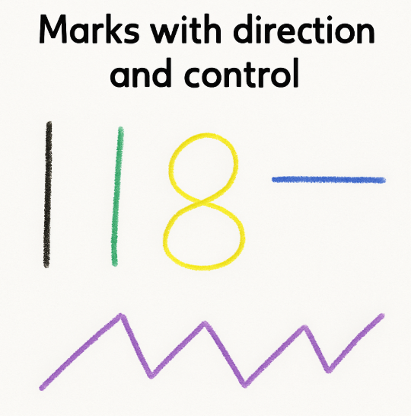 |  | 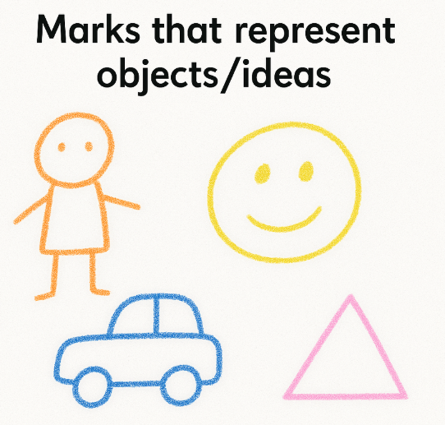
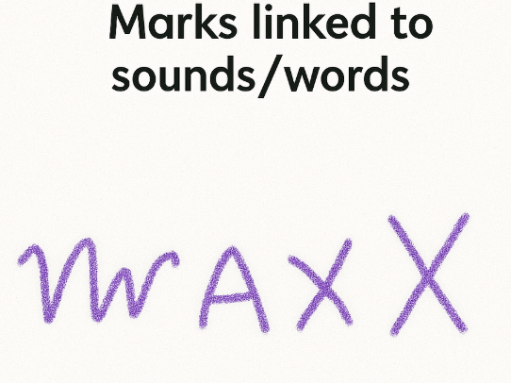 |  | 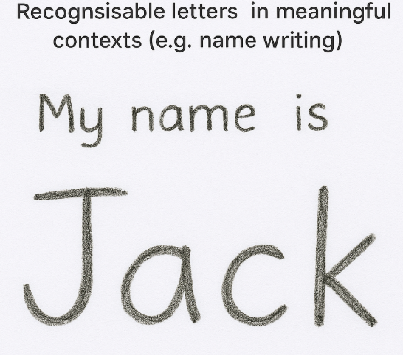
Marks with direction control - Pre-writing shapes and patterns
In Reception, we teach Pre-writing shapes and patterns in Autumn 1 term alongside “squiggle me a writer.” Children move from gross motor control to fine motor control in gradual steps to ensure that they have the prerequisites for writing and muscle strength.
Mastering pre-writing shapes is important in Reception because these strokes are the building blocks of all letter formation. Vertical lines, horizontal lines, circles, diagonals, crosses, squares and triangles are the exact motor patterns that later become letters, numbers and joined strokes. This is done through regular focused drawing in nursery and reception terms to help move our children’s focus and attention to detail.
If children can confidently draw these shapes with control, directionality and consistency first, they have the muscle memory, spatial awareness and visual–motor coordination needed for forming letters accurately, efficiently and legibly when formal writing begins.
Progression in drawing
In Nursery and if required in Reception, we encourage pupils drawing skills so that they move progressively to ensure that by the time they are ready to write they have mastered the above skills. To do this, children need to be able to draw a detailed person. This is the progression we use:
- Head and body attached
- Head, body and limbs attached
- Head, body, limbs, hands and feet
- Head, body, limbs, hands feet, facial features including hair and building to eyelashes and eyebrows
- As above adding pattern to clothing
- As above adding poses for limbs eg. waving a flag, running, holding a kite
- As above adding detail to the environment e.g. trees, animals, presents etc.
Tripod Pencil Grip
Establishing a tripod pencil grip in Reception is important as it allows children to control writing tools with precision, comfort and efficiency. Developing this early prevents poor habits becoming embedded and supports fluent, effortless writing later on, freeing up children’s cognitive load to focus on phonics, spelling and composition rather than the physical act of holding a pencil.
In Reception, we track the chn’s pencil tracker at key points in the year, using this tracker…
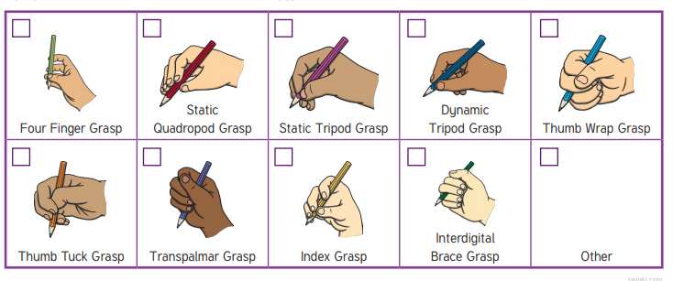
In Reception, we support correct pencil grip by modelling, guiding and practising the tripod hold through daily fine motor experiences, small-world tools, drawing, “Are you Ready to Write?” routines, “Pinch, pinch pinch, flip” and continuous provision – see fine motor development/MTPs for more information.

Foundational Knowledge/skills: Holds pencil with an efficient grip and controls pressure when writing/drawing.
Writing Warm Up
Before engaging in handwriting or fine motor tasks, it is important that children have the opportunity to warm up their hands. Hand exercises help the brain increase awareness of where the hands are, improve coordination, prepare the body for controlled movements and furthermore aid precision.
1. Rub hands together
2. Push palms together
3. Finger stretches
4. Drumming fingers
5. Squeeze forearms and hands
6. Pulling fingers (like taking off a glove)
7. Oppose thumb to each fingertip
8. Finger circle tug
9. Full dough disco

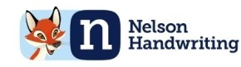
In Reception before adult led writing we chooose four of these exercises (see across) for the start of each lesson. We include a variety each week.

Progression towards Transcriptional Fluency
Letters | Dictated Words |  | Dictated phrase/sentence
Solely teaching letter formation in letter families once children have been taught the phonic element. | Chn only write CVC words once all the letters in these words they can write correctly. |  | Chn that can write CVC words correctly formed using the sounds taught, they can write a dictated phrase/sentence.
How we teach this
Pre-Dictation  - “Are we ready to write?” sequence  - Teacher model and say the formation phrase  - “pointy finger” - Air draw  - “pointy finger” - Draw on hands  - Chn have a go, teacher supporting  - Check they are using the hand they write with  - Pencil tripod grip – “pinch pinch pinch flip”  - My turn, your turn  - Chn use “pointy finger” and put it non the starting position in their book/on the paper to trace. Key they go from the correct starting position.  - Sheet stuck on a w/b for staff to model – teacher model on sheet  - Chn’s turn  - Teacher to address any misconception inc pencil grip  - Write letter 3 times  - Chn self-assess – “Choose your best” – “Best Blue” | Dictation – CVC word  Oral composition around the topic you are going to write about  Teacher models with the child doing it at the same time…  segmenting fingers  Hearing initial sound  Find the initial sound on formation mat  Practice air draw etcc  Then child to write it down  Repeat for middle and final sounds  As chn become more confident with this  Yippee yellow and think pink – however their letter formation should already be correct! |  | Dictation  Oral composition around the topic you are about to write about  Teacher dictates the sentence and holds it for the chn.  Word by word  OR  Sentence by sentence  Foundational Knowledge/skills:  - Uses phonic knowledge to write words and simple dictated sentences that can be read by others.  - Forms most lowercase letters correctly, starting in the correct place and using tripod grip.

Assessment progression and expectations over the year
Autumn 2 end Not on Track | Autumn 2 end On Track
Pre writing shapes and patterns | Letters | Dictated Words | Dictated phrase/sentence
 | Solely teaching letter formation in letter families | Chn only write CVC words once all the letters in these words they can write correctly. | Chn that can write CVC words correctly formed using the sounds taught, they can write a dictated phrase/sentence.
Spring 2 end Not on Track |  | Spring 2 end On Track
Pre writing shapes and patterns | Letters | Dictated Words | Dictated phrase/sentence
 | Solely teaching letter formation in letter families | Chn only write CVC words once all the letters in these words they can write correctly. | Chn that can write CVC words correctly formed using the sounds taught, they can write a dictated phrase/sentence.
Summer 2 end Not on Track |  |  | Summer 2 end On Track  ELG
Pre writing shapes and patterns | Letters | Dictated Words | Dictated phrase/sentence
 | Solely teaching letter formation in letter families | Chn only write CVC words once all the letters in these words they can write correctly. | Chn that can write CVC words correctly formed using the sounds taught, they can write a dictated phrase/sentence.  Foundational Knowledge/skills:  - Uses phonic knowledge to write words and simple dictated sentences that can be read by others.  - Forms most lowercase letters correctly, starting in the correct place and using tripod grip.

