
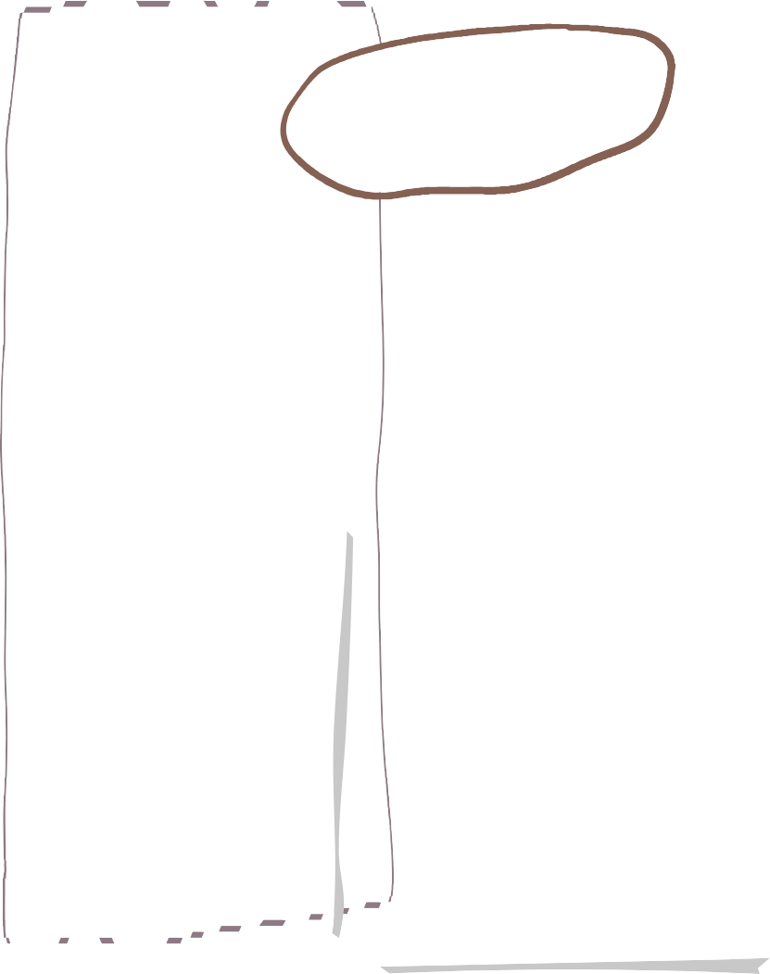




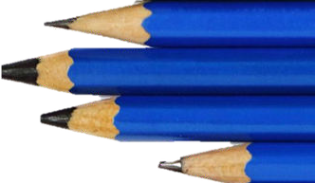
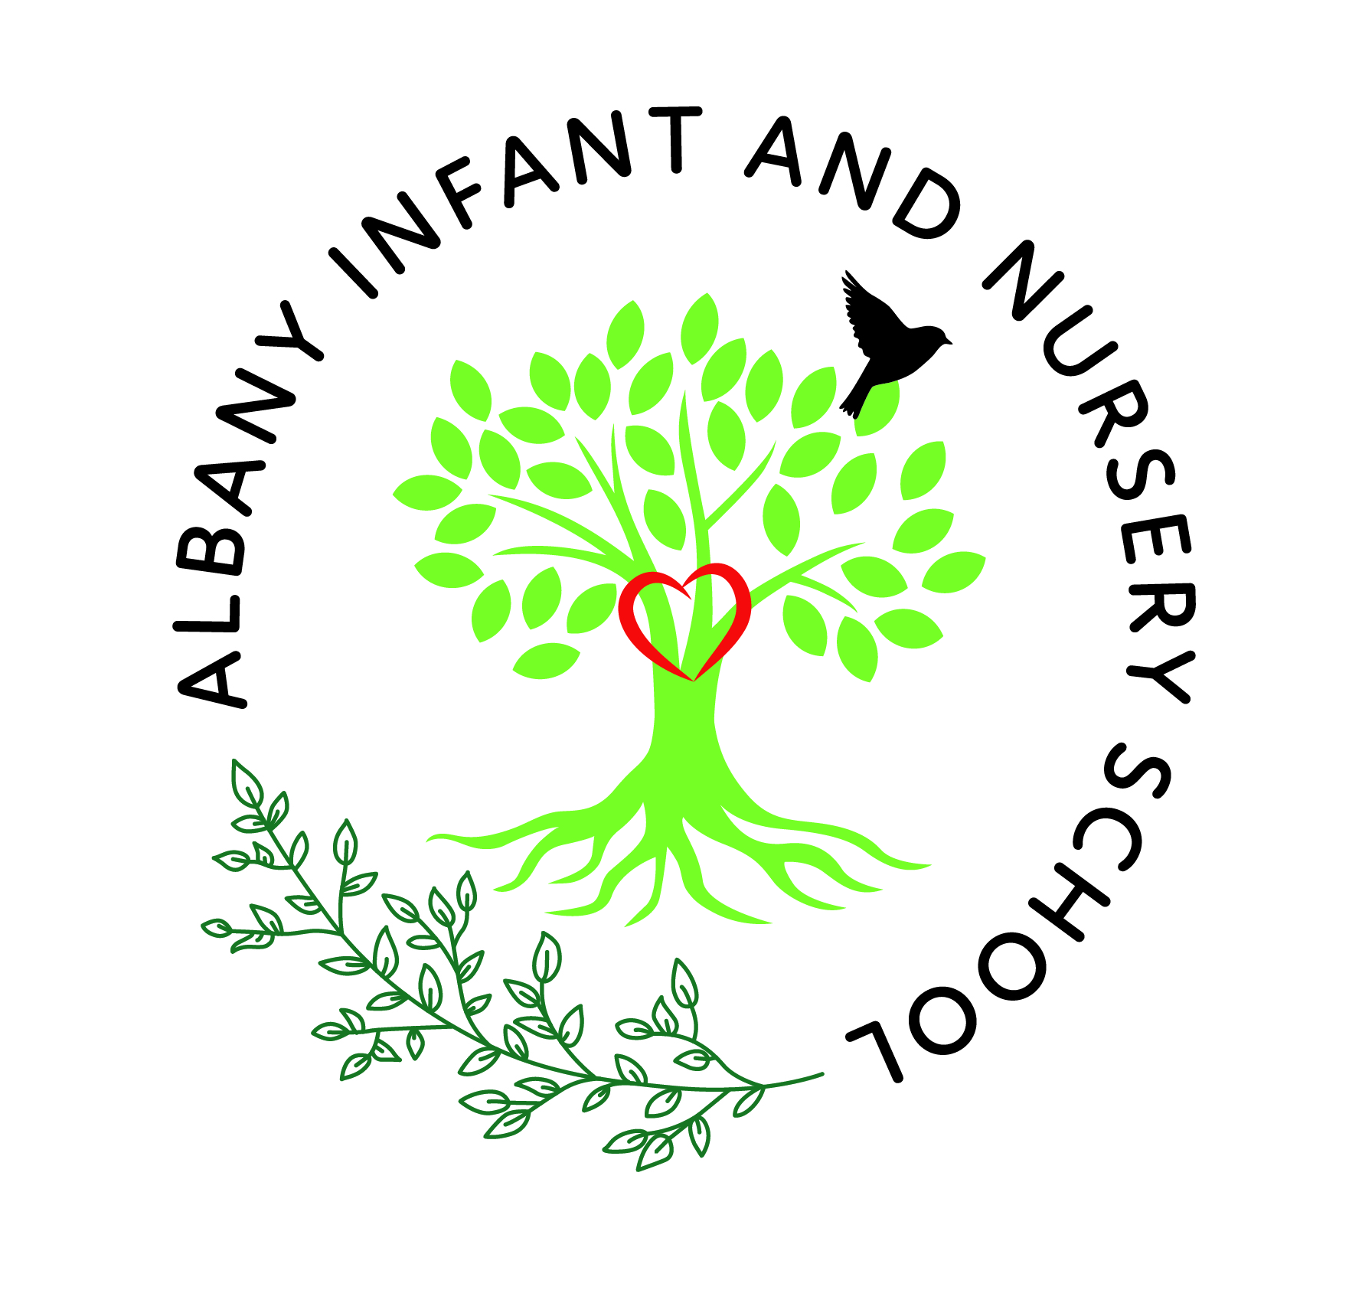

Autumn One in Reception
Maths
Science

Literacy
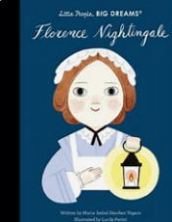
We will be reading, retelling and acting out stories which have been read to us. We will engage in class discussions, asking simple questions to gain deeper understanding and be encouraged to use the new vocabulary taught to us using STEM sentences. We will recall facts about key, significant people and share some similarities and differences from the past to today. We will write recognisable letters and some simple phrases.

We are reading…
This term, we will be exploring objects, shapes and numbers to 5. We will be counting, recognising and learning to write these numbers and explore the patterns of numbers linking these to the written numeral. There will be plenty of mathematical reasoning with numbers as we count, order and subitise (looking at dice patterns) as well as find one more or one less than a given number.
As part of our understanding of the world, we will be talking about our own families and our roles within the community. We will then be exploring the natural world as we prepare for the changes that come in Autumn. We will explore our area in and around school and use our senses to learn more about the natural world. This will provide opportunities to explore, climb, build and create at their own pace and following their own interests.

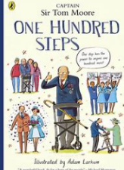
Phonics
Each day we will be teaching a Phonics lesson. This is to help the children apply their knowledge of sounds to letters (graphemes), and applying these to words. We will be teaching them how to segment and blend cvc words. Each child will have their book changed once per week.
We will be learning how to hold a pencil using the tripod grip and know how to apply pressure for different effects.
We will learn the names of the primary and secondary colour and know that these can be chosen for a specific purpose.
We will make props and create products by
carefully selecting appropriate materials to
create a desired effect, justifying their choices
where possible.
Art & DT

Music
History
RE
To develop our artistic and cultural awareness, this term we will sing a range of well-known nursery rhymes and songs. We will perform some of these songs, rhymes, poems and stories with others, and-when appropriate try to move in time with the music. We will also perform in front of an audience for our Nativity performance in December.

To support our understanding of the world and linking closely to our history topic, we will learn about the meaning of special. As a class we will learn about our families, the roles each person has and why they are special to us.
We will discuss the special events we celebrate with our families and learn about when they happen in the calendar year. We will look for similarities and differences between our families and celebrate the uniqueness of them all.
History is our driver for our enquiry learning this term. We will be learning about the past and what this means. As well as relating to events that have happened in the children’s lives, we will be learning about key events and people in history. Our focus will be on Florence Nightingale, Mary Seacole and Sir Captain Tom Moore. We will learn about these significant people and how they changed our world for the better.

PE
PSHE
We have two PE lessons per week which enable us to develop our knowledge and skills in two different areas. This term, we are learning about gymnastics and dance. In gymnastics we are learning how to travel in confidence and skill both in around, up and over, and through equipment. In dance, we are learning how to copy a short repetitive routine and know what makes an action successful when it’s performed.
This term we will be focusing on establishing routines and developing independence with toileting and getting changed for PE. We will focus on developing positive relationships with classmates and staff and discuss how to be kind, proud and safe in our school community.
We will learn how to demonstrate empathy by being a good friend to others as well as being able to show resilience and perseverance when faced with a challenge.


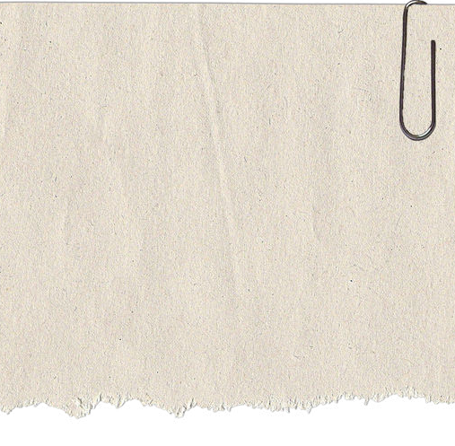

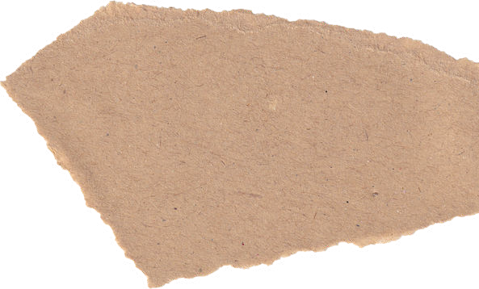


We will be utilising simple devices such as iPads, Bee Bots and computers to develop our digital literacy. We will learn how to complete a simple program and follow simple instructions. We will know that information can safely be retrieved from devices under adult supervision.
Computing

