Albany Infant and Nursery School
Reception Handwriting Progression Document
Mark Making Opportunities
Nursery | To know how to sit upright without leaning or resting on a support  mark making of vertical lines, horizontal lines and circles  physical literacy  funky fingers  dough disco  squiggle whilst you wiggle  enhancements in provision (indoor and outdoor)
Reception | ELG:  - Hold a pencil effectively in preparation for fluent writing – using the tripod grip in almost all cases.  - Use a range of small tools, including scissors, paint brushes and cutlery.  - Write recognisable letters, most of which are correctly formed  To know how to sit appropriately on a chair with their feet on the floor for short periods of time.  Begin to show accuracy and care when drawing  mark making opportunities of: imitating and copying crosses, squares, right and left diagonal lines, letters and numbers  writing own name and numbers  drawing a recognizable face with eyes, nose, mouth, drawing a basic stick figure with 2-4 body parts  colouring inside a circle and filling it at least halfway  physical literacy  funky fingers  dough disco  squiggle me into a writer  daily handwriting  enhancements in provision (indoor and outdoor)

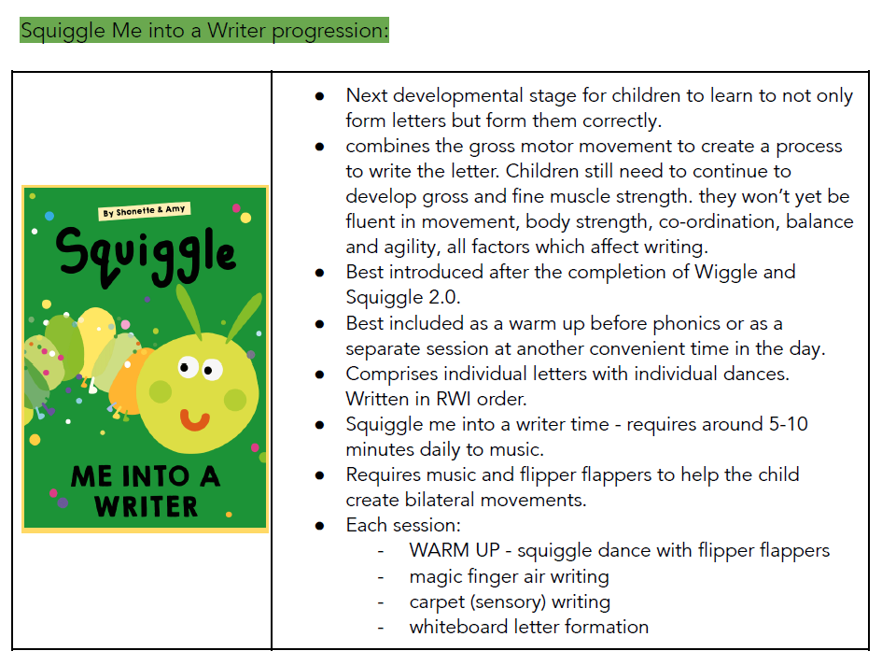
Letter family | Letter | Language | HW Unit
Set 1:  c, a, o, d, g, q, e  ‘Let’s go round again’  Average White Band - Let's Go Round Again | c | Start at the top, and go round. | 17
 | a | Start at the top. Go all the way round, up to the top, down and flick. | 6
 | o | Start at the top, and go all the way round. | 16
 | d | Start at the middle. Go all the way round, all the way up to the top | 13
 | After teaching the 4 letters Monday to Thursday, revisit all 4 letters in the Friday session – revisit, review and consolidate.
 | g | Start at the top. Go all the way round, up to the top, straight down, and round. | 15
 | q | Start at the top. Go all the way round, up to the top, straight down, and flick.
 | e | Start near the bottom. Go up, around, and down. | 21
 | After teaching the 4 letters Monday to Thursday, revisit all 4 letters in the Friday session – revisit, review and consolidate.
Set 2:  i, l, t, u, j, y, h, k, b  ‘Reach for the stars!’  Bing Videos | i | Start at the top. Go straight down, and flick. Lift your pencil and put a dot at the top. | 10
 | l | Start at the top. Go straight down, and flick. | 27
 | t | Start at the top. Go straight down, and round. Lift your pencil, and cross the ‘t’. | 7
 | u | Start at the top. Go down, round, back up to the top, down, and flick. | 22
 | After teaching the 4 letters Monday to Thursday, revisit all 4 letters in the Friday session – revisit, review and consolidate.
 | j | Start at the top. Go straight down, and round. Lift your pencil and put a dot at the top. | 29
 | y | Start at the top. Go down and round, back up to the top, then straight down, and round. | 33
 | h | Start at the top. Go straight down, up and over, down, and flick. | 24
 | k | Start at the top, and go straight down. Lift your pencil and place it next to the middle. Go into  the middle, out from the middle, and flick. | 18
 | After teaching the 4 letters Monday to Thursday, revisit all 4 letters in the Friday session – revisit, review and consolidate.
 | b | Start at the top. Go straight down, back up, and all the way round. | 25
Set 3:  r, n, m, p, s, f  ‘Mama do the hump'  Rizzle Kicks - Mama Do The Hump [CDQ] - YouTube | r | Start at the top. Go straight down, back up and over, and flick. | 23
 | n | Start at the top. Go down, up and over, down and flick. | 11
 | m | Start at the top. Go down, up and over, down, up and over, down, and flick. | 12
 | h | Start at the top. Go straight down, up and over, down, and flick. | 24
 | After teaching the 4 letters Monday to Thursday, revisit all 4 letters in the Friday session – revisit, review and consolidate.
 | k | Start at the top, and go straight down. Lift your pencil and place it next to the middle. Go into  the middle, out from the middle, and flick. | 18
 | b | Start at the top. Go straight down, back up, and all the way round. | 25
 | p | Start at the top. Go straight down, up to the top, and all the way round. | 8
 | s | Start at the top. Go round, down, and back round. | 5
 | After teaching the 4 letters Monday to Thursday, revisit all 4 letters in the Friday session – revisit, review and consolidate.
 | f | Start at the top. Go round, and straight down. Lift your pencil, and cross the ‘f’ in the middle. | 26
Set 4:  v, w, x, z  ‘Up and down' Venga Boys  Vengaboys - Up and Down (original) | v | Start at the top. Go down, and back up to the top. | 30
 | w | Start at the top. Go down, back up to the top, down, and back up to the top. | 31
 | x | Start at the top. Go down to the bottom. Lift your pencil to the top, and down across the  other way. | 32
 | z | Start at the top. Go straight across, diagonally to the bottom, and across. | 34
 | After teaching the 4 letters Monday to Thursday, revisit all 4 letters in the Friday session – revisit, review and consolidate.

