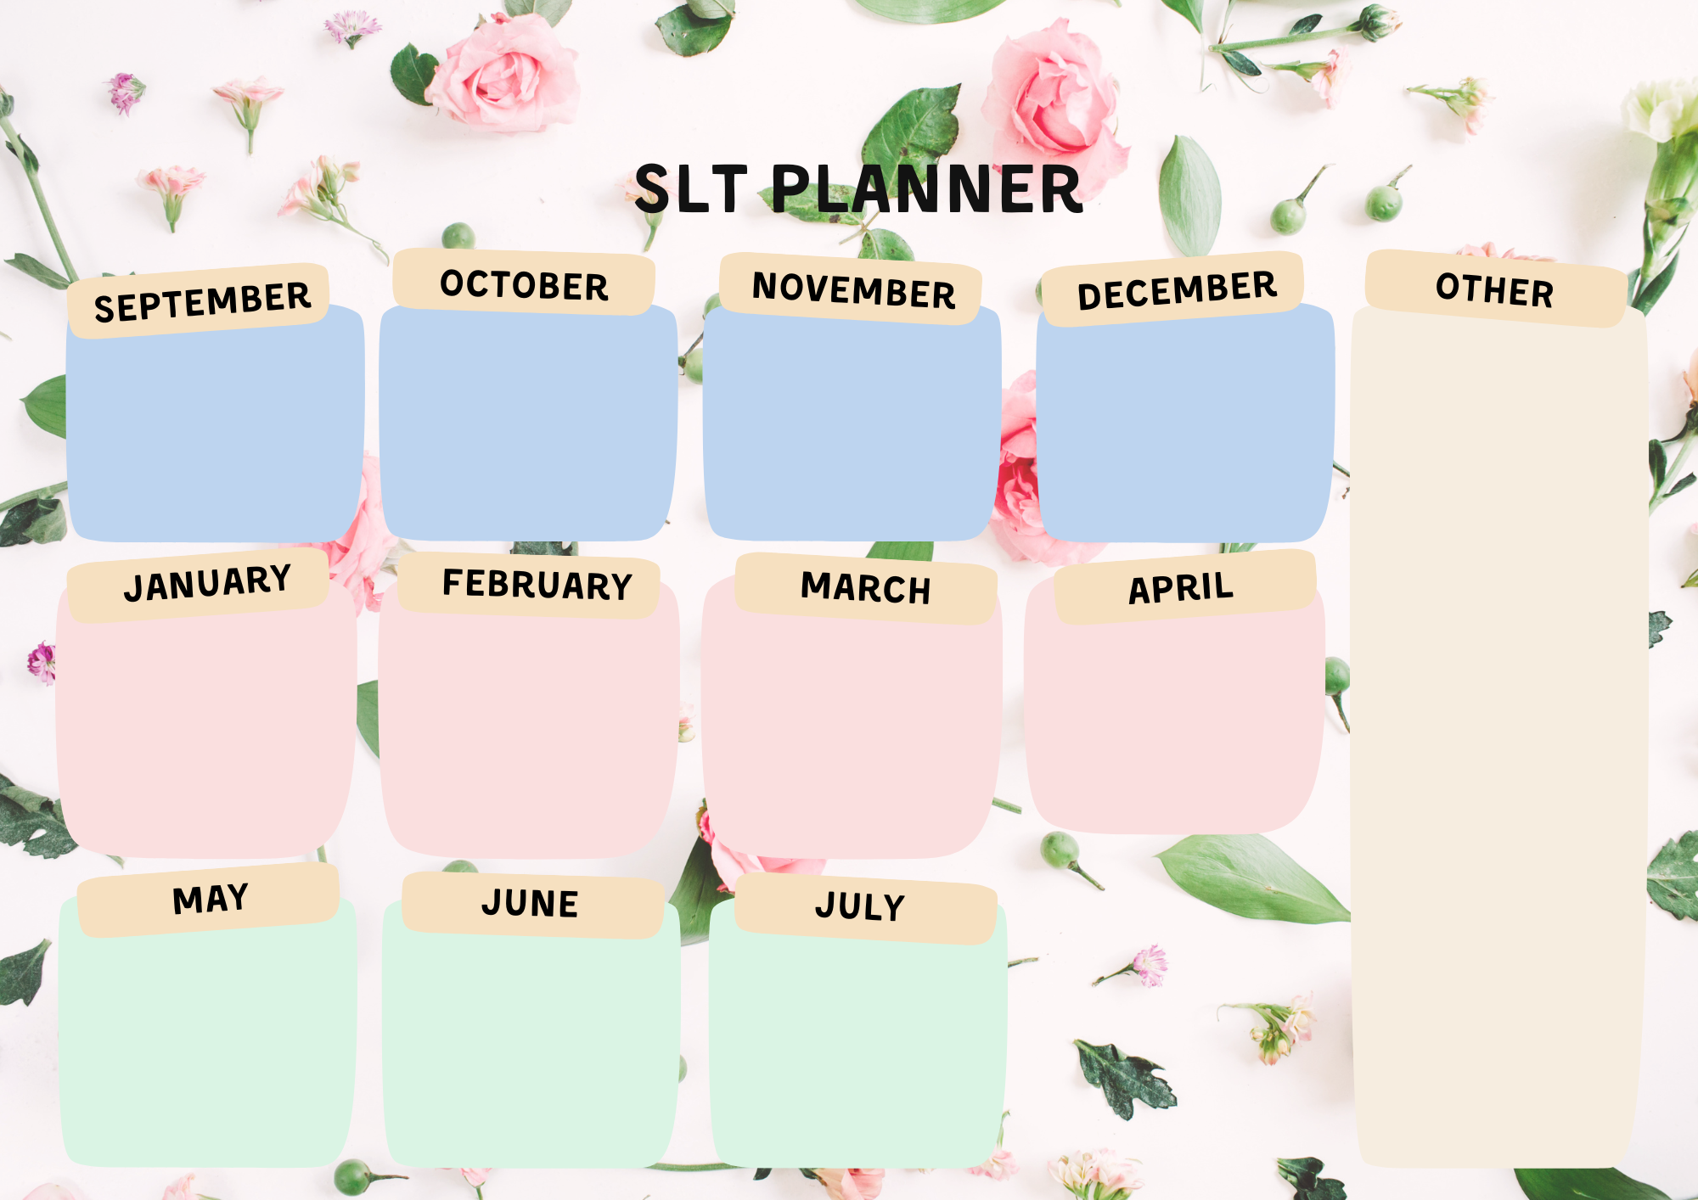
3rd School reopens
21st Children in need – Non uniform day
11th Remembrance commemorations
17th – 21st Anti bullying week
1st School reopens
19th June Father’s Day breakfast
19th June sport’s day
Rec / KS1 1:30pm
Nursery 11am and 2:45pm
SEND coffee morning TBC
4th Bank Holiday – school closed
11th – 17th Mental health week
Spring disco TBC
22nd INSET DAY
5th World book day – wear pyjamas
10th / 11th Parents Evenings
13th Mother’s Day Breakfast
26th Easter bonnet parade and Easter Fayre and last day of term.
27th INSET.

BLACK HISTORY MONTH
1st Phonic workshop evening
14th / 15th parents evening
School photographs
SEND Coffee morning
17th Last day of term

Parent’s Diary 2025-26
SUMMER FAYRE TBC
10th Reports out to parents
15th Optional parents evening
24th Last day of summer term
27th INSET
3rd December 12 days of Christmas begins
CHRISTMAS FAYRE
10th Foundation Nativity am/pm
12th Year 1 performance
Year 2 Carol service TBC
19th December INSET day
1st INSET
2nd Children return to school
5th New starters coffee morning
26th Phonic workshop

Termly class-based celebrations termly
Class newsletters first week of each new term – autumn, spring, summer
Panto trips in December
School trip overview for each year group to be sent separately
Transition day 2026 TBC
Stay and play for Nursery TBC
School open evenings for new parents
Sat 11th October
Thurs 13th November
Sat 6th December
Tuesday 6th Jan

Albany Infant and Nursery School

FILM NIGHT TBC
13th last day of Term
10th Internet safety day
Phonics workshop – Year 1 TBC

5th Return to school
SEND Coffee morning

13th Summer term starts

