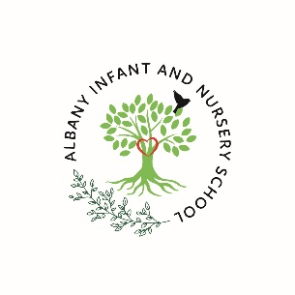
Albany Infant and Nursery School
Grenville Drive, Stapleford NOTTINGHAM NG9 8PB
Telephone 01159179212
Email office@albany-inf.notts.sch.uk
Headteacher Ms Kirsten O’Neill

Friday 25th April 2025

Dear Health and Safety Advisors,
Please see the below letter from OPAL.
Information for Local Authority leads for Health and Safety in relation to OPAL schools
A school in your local authority has recently signed up for the OPAL Outdoor Play and Learning Primary Programme. This multi-award-winning school improvement programme supports schools to take a strategic approach to play, helping them develop key areas around leadership, policy, risk management, environment, staffing, resourcing and playwork training, all of which lead to the transformation of school playtimes.
The programme has been developed and proven effective in hundreds of primary schools by OPAL CIC, the UK’s leading not-for-profit consultancy on school improvement through play.
From the start of the programme, the school will continually improve all aspects of their play environment, introducing play zones such as: mud kitchens, digging areas, wheel zones, performance areas, loose parts, and creative areas, and may also acquire items such as caravans, boats and in some schools, even cars and buses. Providing such spaces brings school grounds alive, promoting creativity, problem-solving, and social skills and helping children develop confidence and resilience.
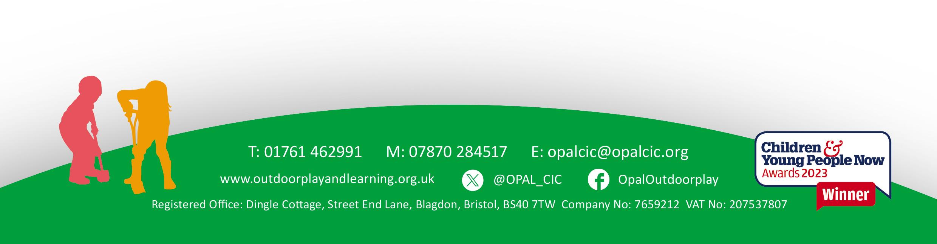
Obesity and mental health are seriously reducing children’s life chances; schools that improve their play offers have seen considerable impact and positive benefits in both areas. The risks from child inactivity are also huge; 11 out of 12 primary children no longer have the basic core strength levels that children did in 1984. It is, therefore, essential for children's well-being for them to learn to be active, competent, and resilient. All current best practice advice says that we protect children by allowing them to encounter, identify and mitigate risk for themselves in a managed environment and that removing beneficial challenging activities should be reserved for those with an unacceptable risk of death or serious injury.
The training elements of the OPAL programme aim to ensure staff feel confident and are competent in supporting and making decisions around children’s risk and play using a common-sense approach.
All schools must understand that risk management’s purpose is to maintain benefits and not eliminate all risks. They must also accept that the possibility of even serious or life-threatening injuries cannot be eliminated, though it should be managed. OPAL's guidance, which originates from experts such as The International Standards Organisation (ISO) regarding ISO 4980, RoSPA, The Play Safety Forum and the HSE regarding the High-Level Statement on Managing Risk in Play and Leisure, the DFE, which refers back to the HSE document, the Child Accident Prevention Trust, is the best advice available. We will be following OPAL's R.A.P.I.D 5-point approach, which helps schools strike a balance between the benefits and risks offered through their outdoor play provision.
- R = Risk-Benefit Assessment (written, involving children and staff)
- A = Assemblies for pupils to discuss risk, agree on rules and negotiate changes needed to provision
- P = Policy adopting the HSE guidance on risk and play. Including clarification around the adoption of ranging supervision across the site where possible (ratified by Governors)
- I = inspections for fixed play equipment, the grounds and loose parts (e.g. ROSPA, arboriculture yearly inspection and visual daily checks on loose parts)
- D = Dynamic risk assessment -common sense approach used by competent staff
OPAL bases its approach on the highest level of advice available from the Health and Safety Executive, and we can draw on all of the most experienced advisors on the subject to inform our work, including Professor David Ball, Tim Gill, Adrian Voce and Bernard Spiegel, all of whom sat on the National Play Safety Forum panel to draw up the high level ‘Statement on Managing Risk in Play and Leisure’ (H&SE 2000). Amanda Spielman, former head of OFSTED, voiced her support for the HSE statement, and OFSTED frequently cites OPAL’s work as having a hugely positive impact on schools.
OPAL has been successfully implemented in over 1200 UK schools and was awarded a quarter of a million pounds by Sport England in 2019 to expand its reach to as many primary schools in England as possible. The RAPID approach developed and adopted by OPAL was approved by Zurich Municipal, the UK’s largest insurer of local authorities and schools. Impact data from hundreds of schools highlight the number of accidents and incidents reduced after implementing the OPAL programme.
One of our Senior Mentors sat on the National Play Safety Forum alongside the Health and Safety Executive for many years. OPAL is currently an adviser to the All-Party Parliamentary Group on Fit and Healthy Childhood and is cited in several of their reports.
Here is a list of related articles which we recommend to schools:
https://issuu.com/playwales/docs/play_and_risk_2021?fr=sZjhhYzM2NDMxNzk
https://www.hse.gov.uk/entertainment/childrens-play-july-2012.pdf
Call for your support
We hope that you are supportive of schools adopting our approach. The standards and expectations of schools implementing OPAL are extremely high.
We encourage any Health and Safety Officer to contact us if they have concerns about how any school manages risk and challenges associated with the programme or if they are no longer upholding the standards and procedures OPAL has advised.
Please feel free to get in touch should you wish to find out any further information about the OPAL programme or any area addressed in this information sheet.
OPAL Managing Director: Michael Follett BAHons. PGCE
OPAL Outdoor Play and Learning CIC national office: outdoorplayandlearning@gmail.com
Your regional OPAL mentor is:
Bobby Beaumont
bobby@opalcic.org

Many thanks for taking the time to read this letter about our upcoming, exciting improvements.

Yours sincerely
Ms Kirsten O’Neill
Head Teacher

Appendix
The High-Level Statement on Managing Risk in Play and Leisure (HSE 2012): https://www.hse.gov.uk/entertainment/childrens-play-july-2012.pdf
Managing Risk in Play Provision - Implementation Guide: https://dera.ioe.ac.uk/8625/1/00942-2008DOM-EN.pdf
DFE reference to the above: https://www.gov.uk/government/publications/health-and-safety-advice-for-schools/responsibilities-and-duties-for-schools
International Standards Organisation ISO Standard 4980: https://docs.google.com/document/d/14Yo68ugJdO7Jzto-64MqUFZW3wGdsmzWpJW0mSI8Qys/edit

